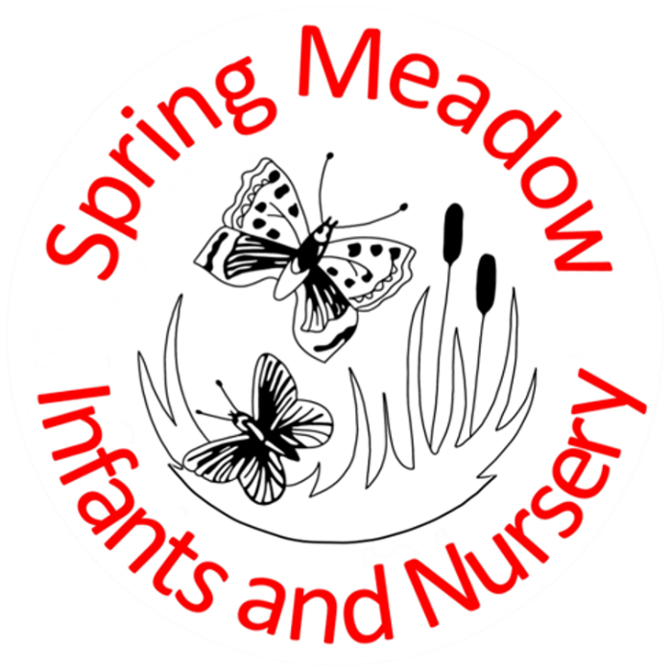

**Nursery Admissions Policy**

**September 2024**

|  |  |
| --- | --- |
| **Lead author/initiator(s):** | Laura Fielding |
| **Next Review Date:** | September 2025 |
| **Version No:** | 3 |
| **Ratified by:** | Spring Meadow Infant and Nursery School Local Governing Body |
| **Date Ratified:** | September 2024 |
| **Review Timetable:** | Annually |

**Spring Meadow Infant Nursery Admissions Policy**

**Contents:**

1. Statement of Intent
2. Legal Framework
3. Aim
4. Nursery Timings
5. Applying for a Place
6. Waiting List
7. Forms to be Completed by Parents
8. Early Years Education Funding (EYEF)
9. Paid Sessions

**1. Statement of Intent**

It is our intention to make our Nursery accessible to children and families from all sectors of the local community. We are committed to being as inclusive as possible regarding our admissions for our Nursery. We also strive to be a provider of funded childcare without it impacting the quality of our provisions. This policy outlines our approach to Nursery admissions, our admissions criteria, and our plans for offering funded childcare in a sustainable and inclusive manner.

**2. Legal Framework**

This policy relates to the Early Years Foundation Stage Statutory Framework.

**3. Aim**

* To ensure that Spring Meadow Nursery is accessible to all sectors of the community, through open, fair, and clearly communicated procedures.
* To promote smooth and stress-free transitions to the setting, ensuring both children and parents/carers are happy.
* To ensure the Nursery complies with the legal space requirements set out in the Early Years Foundation Stage (EYFS).

**4. Nursery Timings**

Our Nursery provision is open for 30hrs a week, 38 weeks a year. The sessions are split into mornings and afternoons.

Morning Sessions are 9.00-12.00

Afternoon Sessions are 12.00-15.00

The afternoon session includes a 30 minute lunch from 12.00-12.30.

Children are able to attend for full days between 9.00-15.00

Children who attend 30hrs a week are in school from 9.00-15.00.

**5. Applying for a Place**

In order to apply for a place at Spring Meadow Nursery, parents must complete an admissions form which can be obtained from the school office. Once this form has been completed and returned with the child’s birth certificate, a copy of which will be taken, the child will then be added to the admission list. We only take children the term after their 2nd birthday. Prior to starting at Nursery, parents are required to sign a contract and a home visit will be carried out by Nursery staff. Spaces in the nursery will vary for each session to ensure we are compliant with statutory ratios. Ratios for 3 year olds is 1:8 and for 2 year olds is 1:5.

Funded places may be withdrawn if a child does not attend regularly unless there are special circumstances, and these are agreed with the provider. Typically, if a child does not attend for four weeks their place will be withdrawn unless they are in hospital.

**6. Waiting List**

The names of children to whom we cannot offer places at the initial allocation stage will automatically be placed on our waiting list. The waiting list will be prioritised firstly by the following admissions criteria:

* Age, we will take admissions by date of birth.
* Children in Care (CIC), also known as Looked After Children (LAC), and children who were previously Looked After but ceased to be so by reason of adoption, a residence order (now known as a child arrangement order) or special guardianship order.
* Children who appear to have been in state care outside of England and ceases to be in state care as a result of being adopted.
* Children living in the catchment area with a sibling at the school (or partner junior school) at the time of admission.
* Children living in the catchment area.
* Children living outside the catchment area who have a sibling at the school (or partner junior school) at the time of admission.
* Children of members of staff, providing that they have been employed for a minimum of two years and/or are recruited to fill a vacant post for which there is a demonstrable skills shortage.
* Children who live outside the catchment area, but nearest the school as measured by a straight line.

Parents must ensure that any change of address is notified to the school in writing

A child may be refused admission only if the Nursery is full to the admissions limit or if the child is not of the appropriate age. There is no right of appeal against the refusal to award a place in Nursery, since there are statutory criteria governing adult: pupil ratios that cannot be over-ridden. Places will only be allocated where it is safe and within the legal ratios.

**7. Forms to be Completed By Parents**

Prior to a child attending our preschool, parents must complete and sign a contract and admission form. These forms provide the preschool with personal details relating to the child. For example, name, date of birth, address, emergency contact details, parental responsibilities, dietary requirements, collection arrangements, fees, and sessions, contact details for parents, doctor’s contact details, health visitor contact details, allergies, parental consent, and vaccinations etc.

**8. Settling In**

Once a place has been offered each child will have a home visit, this is to give parents the opportunity to talk through any specific needs their child may have. It also gives members of staff the chance to see the children in a setting they are comfortable in and get to know them. Children will complete an induction session before starting full sessions, these will last 1 hour and parents will be able to stay with their children. Subsequent settling in sessions will be organised to meet the specific needs of the child if the nursery staff feel it would be beneficial. This process can take up to 2 weeks (sometimes longer), but it is important that child, parent, and nursery are happy before a child attends their full sessions. The settling process is viewed as an essential part of ensuring children have a positive time at nursery and we will be flexible in extending this period and offering families additional support.

**9. Early Years Education Funding (EYEF)**

Spring Meadow are in receipt of EYEF for 2, 3 and 4 year-olds. Working parents are entitled to 15 hours funded hours for children who are 2 years old. To check if you are eligible please see [www.childcarechoices.gov.uk](http://www.childcarechoices.gov.uk/). All 3 and 4 year-olds are entitled to the Universal 15 funded hours during term time This is available from the term following your child’s third birthday.

To access this funding, you need to complete a EYEF form and show your child’s birth certificate to the school office.

30 Hour Funded / Stretched Offer Agreement:

Our Nursery is open 38 weeks of the year. The Nursery can offer **30-hours per week funded Extended Nursery sessions** from 9am-3pm for those parents eligible to claim a 30-hours place for their child. To check if you qualify to claim for the 30-hours funded sessions, please see [www.childcarechoices.gov.uk](http://www.childcarechoices.gov.uk/) and follow the online application process to obtain your unique Eligibility Code. This must be provided to us to secure a 30-hours place at Spring Meadow Nursery.

Each child’s maximum free entitlement for both the ‘Universal’ and the ‘Extended’ offer will be the same, 570 hours per year.

**10. Paid Sessions**

We can offer additional nursery sessions for parents who wish their child to attend more than their funded hours at the following rates:

2 year olds: £25 per session

3 year olds: £18 per session

These sessions will need to be organised through the school office and a contract signed. Additional sessions will only be offered if there is availability and will be on a first come first served basis. Lunches are on offer for children who attend an afternoon session at a cost of £2.20.

If your child is ill or your child is unable to attend it would still be expected the session would be paid for due to already organising staff ratios.

Should you wish to withdraw your child from Nursery, we will require one half term’s notice.  Fees will be due during this notice period for the agreed sessions, regardless of whether your child attends the setting during this time. It would be expected that there will be a charge for all booked sessions even if your child does not attend.