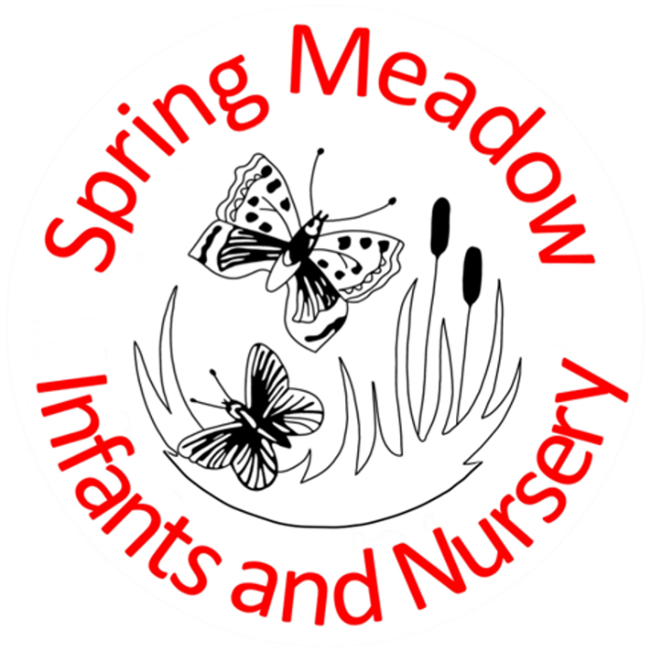
Children who are Looked After or Previously Looked After Policy
February 2024
Lead author/initiator(s): | Laura Fielding
Next Review Date: | Feb 2025
Version No: | 2
Ratified by: | Spring Meadow Infant and Nursery School Local Governing Body
Date Ratified: | 8.2.2024

Spring Meadow Infant and Nursery School
Contents:
- Statement of Intent
- Roles and Responsibilities
- Policy and Procedures

Designated Person for Children in Care and Previous Children in Care- Miss Libby Cross (Assistant Headteacher)

1. Statement of intent
At Spring Meadow Infant and Nursery School, we recognise that ‘Looked After Children’ (LAC) and ‘Previously Looked After Children’ may have very specific needs and may be coping with trauma, abuse or rejection, and are likely to experience personal distress and uncertainty.
Educational achievement and subsequent life chances for looked after and previously LAC are of real concern. Children who are looked after require special treatment and additional attention in order to improve their situation. Spring Meadow Infant and Nursery School endeavours to provide positive experiences and offer stability, safety, and individual care and attention, for all our children.
This will be achieved by:

- Placing the highest priority on their education
- Promoting regular attendance
- Having high expectations and aspirations
- Promoting access and inclusion in all areas of school life
- Promoting stability and continuity
- Supporting early intervention
- Valuing the voice of the child
- Promoting social, emotional and mental health and well-being
- Working in partnership with parents, carers, social workers and other professionals

  - Guiding Principles

- The voice of the child is of paramount importance
- All LAC or previously LAC children will receive high quality education which is inspiring and challenging, resulting in the best possible outcomes, thus closing the educational gap between these children and those who are not care experienced
- Every LAC or previously LAC child will have a positive educational experience which promotes social and emotional learning and wellbeing alongside academic success to ensure readiness for adulthood
- Spring Meadow Infant and Nursery School will meet the needs of LAC or previously LAC children through effective liaison and integrated work with all key partners including the relevant Virtual School

  - Definitions

Under the Children Act 1989, children in care are looked after by a Local Authority if he or she is in their care or provided with accommodation for more than 24 hours by the authority. This can happen under a number of arrangements.

- Children who are accommodated under a voluntary agreement with their parents (section 20)
- Children who are the subject of a Care Order (section 31) or Interim Care Order (section 38)
- Children who are subject to emergency orders for their protection (sections 44 and 46)
- Children who are compulsorily accommodated - this includes children remanded to the Local Authority or subject to a criminal justice supervision order with a residence requirement (section 21).

Children who have previously been in care include those children that are no longer in care through:

- Adoption
- A Special Guardianship Order (SGO)
- A Child Arrangement Order (CAO)

2. Roles and Responsibilities

2.1 The Head Teacher and Governing Body

We, the Headteacher and Governing Body of Spring Meadow Infant and Nursery School are committed to promoting improved educational life chances for all LAC or previously LAC children. We will ensure that the Designated Teacher for children in care has qualified teacher status, appropriate seniority and sufficient time and experience to fulfil this statutory role.

A named governor will be nominated to link with the Designated Teacher and all governors will be fully aware of the statutory guidance for LAC or previously LAC children.

The Head Teacher and nominated governor will monitor the role of the Designated Teacher to ensure that all LAC or previously LAC children make accelerated and rapid progress and that the whole school staff have relevant skills, knowledge and understanding.

Regular communication between the Head Teacher and Governing Body and the Designated Teacher should include:

- The number of care-experienced children on roll
- Compliance and quality of individual children’s Personal Education Plan (for Children in Care)
- The use and impact of the Pupil Premium Plus grant in raising educational outcomes
- Attendance and exclusion data (in comparison to children who are not LAC or previously LAC)
- Progress and attainment data (in comparison to children who are not LAC or previously LAC)
- Destinations for LAC or previously LAC children that leave Spring Meadow

2.2 The Designated Teacher for Children in Care (DT)
The Designated Person for Children previously in Care (DP)

Our Designated Teacher and Designated Person of Spring Meadow Infant and Nursery School will:
- Have a full understanding of relevant statutory guidance and attend relevant training as required
- Have a lead responsibility in promoting and raising the educational achievement of every care LAC or previously LAC child on the school roll
- Ensure every child in care has a high quality up to date Personal Education Plan (PEP) and regularly monitor the progress towards desirable outcomes
- Monitor the effective spend of the pupil premium plus grant to maximise educational outcomes for children in care
- Ensure the social, emotional, mental health and well-being needs of LAC or previously LAC children are recognised and prioritised
- Take the lead responsibility for helping all school staff to understand the factors that can affect how care-experienced children learn and achieve, any barriers they might face and the impact of trauma and poor attachments
- Act as the key liaison professional for other agencies and individuals in relation to care-experienced children
- Share confidential and personal information on a need to know basis only
- Actively encourage and promote home learning and extra-curricular activities
- Recognise the impact of transition and plan accordingly

2.3 Spring Meadow Infant and Nursery School Staff

Our staff will ensure their part in embedding a ‘LAC friendly culture’ which is attachment-aware and trauma-informed. This may include attending training, referring to the Designated Teacher for advice and sharing accurate information and data with the Designated Teacher. Our staff will hold high expectations of and aspirations for care-experienced children.

3. Policy and Procedure

3.1 Staff Development and Training

We, the Head Teacher and Governing Body of Spring Meadow Infant and Nursery School will ensure that the Designated Teacher and Designated Person are trained for the role when they come to post and will continue to support them to access ongoing professional development pertinent to the role. All staff are encouraged to participate in training that will enable them to meet the needs of care-experienced children more effectively and the Designated Teacher will raise awareness of typical issues and barriers for these children at a whole school level.

3.2 Admissions

In line with national guidance Spring Meadow Infant and Nursery School prioritises the admission of LAC children.

The importance of a thorough and planned transition is recognised, and this may include:

- Transition meetings between schools
- The swift transfer of information between schools
- Additional school visits and identification of staff mentor and/or peer buddy
- Additional support and planning for care-experienced children at times of transition
- Structured activities to ‘say goodbye’, in recognition of the impact of broken attachments and loss

3.3 Attendance and Punctuality

School attendance procedures will reflect the specific needs of LAC or previously LAC children. This may include reasonable adjustments such as celebrating 100% attendance despite incidents of non-attendance due to care placement moves.

Where there is a concern about attendance or punctuality Spring Meadow Infant and Nursery School will speak to the child, carer / parent, social worker and other relevant professionals including the Virtual School where a child is in care.

3.4 Exclusions

Spring Meadow Infant and Nursery School will make every effort to avoid excluding a LAC or previously LAC child, in recognition of the impact of their early experiences and what their behaviour may have been communicating. We also recognise there may be increased risk of disengagement from school, due to their early experience of broken attachments and loss.

If the child is in care, before acting, we will discuss the rationale for exclusion with the relevant Virtual School. The Virtual School may be contacted for advice if the child was previously in care, with consent from the carers / parents. If there is no option other than exclusion, then we will make every attempt to reduce the number of days of the exclusion and ensure that educational provision is in place from day one (for children in care). Exclusion will not be used as a sanction, but instead will be used to plan successful access, inclusion and reintegration.

3.5 Pupil Premium plus (PP+)

Where a LAC child is allocated pupil premium plus, it is to be used for the benefit of their educational needs. Spring Meadow Infant and Nursery School will ensure that:

- The allocation of PP+ promotes high aspirations and seeks to secure the best educational outcomes
- The extra funding provided by the PP+ reflects the significant additional barriers faced by CYP in care
- For children in care, the allocation of PP+ will be linked to clear desirable outcomes as identified in the Personal Education Plan (PEP)

3.6 Pupils with SEND
Support for LAC with SEND, who do not need an EHC plan, will be covered as part of the child’ PEP and care plan reviews. The SENDCo, class teacher, designated teacher and specialists will involve parents/carers when considering interventions to support their child’s progress. If appropriate, the VSH will be invited to comment on proposed SEND provision for previously-LAC.

