Supporting challenging behaviours Policy
February 2024

Lead author/initiator(s): | Laura Fielding
Next Review Date: | February 2026
Version No: | 2
Ratified by: | Spring Meadow Infant and Nursery School Local Governing Body
Date Ratified: | 8.2.2024
Review Timetable: | Bi-annually

1. Introduction

This policy is recommended to be referenced within the school’s Behaviour Policy; it will be part of a graded response, and needs to be agreed in consultation with staff, Governors, parents/carers, and pupils. The behaviour policy should aim at improving educational outcomes for all pupils by promoting and supporting their engagement with education. It also connects to, and should be consistent with, policies on Health and Safety, Child Protection and Safeguarding, Equal Opportunities, and SEND.

Cambridgeshire Steps training covers two distinct developmental areas:

“Step On” – (De-escalation training) It is considered best practice that all teachers, TA’s and MSA’s complete this de-escalation training. ‘Step On’ is a therapeutic approach to behaviour management, with an emphasis on consistency, on teaching internal discipline rather than imposing external discipline and on care and control, not punishment. It uses techniques to de-escalate a situation before a crisis occurs and, where a crisis does occur, it adopts techniques to reduce the risk of harm.

“Step Up” – (Restrictive physical intervention training) provides training on elements of restrictive physical intervention (restraint) and personal safety. This training can only be provided within services where staff have already completed ‘Step On’ training and are still within certification. ‘Step Up’ training is only delivered where there is an audited need with an individual young person who displays dangerous behaviour.

In addition to the Cambridgeshire Steps Training 6 members of the staffing team have been Team Teach Trained. This is an evidence based training which puts the pupil at the centre of every decision. It provides the 6 members of staff with the confidence and strategies they need to de-escalate situation and reduce physical intervention. When de-escalation has not been successful the training has provided staff with guides and restraints to be used. If this occurs this will then be written in to the children Risk Reduction Plan.

At Spring Meadow Infant and Nursery School we believe that pupils need to be safe, to know how to behave, and to know that the adults around them are able to manage them safely and confidently. Only for a very small minority of pupils will the use of restrictive physical intervention be needed. On such occasions, only acceptable forms of intervention are used.

- Staff will take steps in advance to avoid the need for restrictive physical intervention through dialogue and diversion
- Only the minimum force necessary will be used
- Staff will be able to show that the intervention used was a reasonable response to the incident

The majority of pupils behave well and conform to the expectations of our school. We have responsibility to operate an effective behaviour policy that encompasses preventative strategies for managing difficult and dangerous behaviour in relation to the whole school, each class, and individual pupils.
All school staff need to feel that they are able to manage behaviour, and to have an understanding of what difficult or dangerous behaviours might be communicating. They need to know what options are available for managing behaviour, and they need to be free of undue worries about the risks of legal action against them if they use appropriate physical intervention. Parents need to know that their children are safe with us, and they need to be properly informed if their child is the subject of a Restrictive Physical Intervention, including the nature of the intervention, and the rationale for its use.

2. Acceptable Forms of Physical Intervention

“Physical intervention” (PI) is the term used to describe contact between staff and pupils where no force is involved. There are occasions when it is entirely appropriate and proper for staff to have contact or physical intervention (PI) with children, however, it is crucial that they only do so in ways appropriate to their professional role and in relation to the pupil’s individual needs. There are occasions when staff may have cause to have physical intervention (PI) with pupils:
- To comfort a pupil in distress (so long as this is appropriate to their age)
- To gently direct a pupil
- For curricular reasons (for example in PE, Drama, etc)
- First aid and medical treatment
- In an emergency to avert danger to the pupil or pupils
- In rare circumstances, when Restrictive Physical Intervention is warranted (See Below)

Not all children feel comfortable about certain types of physical contact; this should be recognised and, wherever possible, adults should seek the pupil’s permission before initiating contact and be sensitive to any signs that they may be uncomfortable or embarrassed. Staff should acknowledge that some pupils are more comfortable with touch than others and/or may be more comfortable with touch from some adults than others. Staff should listen, observe and take note of the child's reaction or feelings and, so far as is possible, use a level of contact and/or form of communication which is acceptable to the pupil.

It is not possible to be specific about the appropriateness of each physical contact, since an action that is appropriate with one pupil, in one set of circumstances, may be inappropriate in another, or with a different child. In all situations where physical contact between staff and pupils takes place, staff must consider the following:
- The pupil’s age and level of understanding
- The pupil’s individual characteristics and history
- The duration of contact
- The location where the contact takes place (it should not take place in private without others present)

Physical contact must never be used as a punishment, or to inflict pain. All forms of corporal punishment are prohibited. Physical contact shall not be made with the pupil’s neck, breasts, abdomen, genital area, or any other sensitive body areas, or to put pressure on joints. It must not become a habit between a member of staff and a particular pupil. Physical intervention should be in the pupil’s best interest and should only be used with an awareness of the need to differentiate the attachment to staff from the attachment to key adults such as parents and siblings.

To reduce the risk of allegations, all staff should be aware of safer working practice and should be familiar with the guidance contained in the staff handbook/ school code of conduct / staff behaviour policy and Safer Recruitment Consortium document Guidance for safer working practice for those working with children and young people in education settings. https://www.saferrecruitmentconsortium.org/GSWP%20Oct%202015.pdf

3. Definition of “Restrictive Physical Intervention”

“Restrictive Physical Intervention” (RPI) is the term used to describe interventions where the use of force to control a person’s behaviour is employed using bodily contact. It refers to any instance in which a teacher or other adult authorised by the Headteacher has a duty to use “reasonable force” to control or restrain pupils in circumstances that meet the following legally defined criteria.
- To prevent a pupil from committing a criminal offence (this applies even if they are below the age of criminal responsibility)
- To prevent a pupil from injuring self or others
- To prevent or stop a pupil from causing serious damage to property (including their own property)
- There is no legal definition of “reasonable force”. However, there are two relevant considerations:
- The use of force can be regarded as reasonable only if the circumstances of an incident warrant it
- The degree of force must be in proportion to the circumstances of the incident and the seriousness of the behaviour or consequences it is intended to prevent

The definition of Restrictive Physical Intervention also includes the use of mechanical devices (eg splints on the pupil prescribed by medical colleagues to prevent self-injury), forcible seclusion, use of locked doors or changes to a pupil’s environment. It is important for staff to note that, although no physical contact may be made in the latter situations, this is still regarded as a Restrictive Physical Intervention.

Legal defence for the use of force is based on evidence that the action taken was:
- Reasonable, proportionate and necessary
- In the best interest of the young person

This document takes into account DfE Guidance on Use of Reasonable Force July 2013
https://assets.publishing.service.gov.uk/government/uploads/system/uploads/attachment_data/file/444051/Use_of_reasonable_force_advice_Reviewed_July_2015.pdf

Restrictive Physical Interventions may be used when all other strategies have failed, and therefore only as a last resort. All staff should focus on de-escalation and preventative strategies rather than focusing solely on reactive strategies. However there are other situations when restrictive physical intervention may be necessary, for example in a situation of clear danger or extreme urgency. Certain pupils may become distressed, agitated, and out of control, and need calming with a brief Restrictive Physical Intervention that is un-resisted after a few seconds.

The safety and well-being of all staff and pupils are important considerations. Under certain conditions this duty must be an over-riding factor.

4. Who May Use Restrictive Physical Intervention in School

All staff employed by the school, and who have completed the full “Step On” and/or “Step Up” training (as well as the teachers employed at the school) and the 6 staff members with the Team Teach Training are authorised by the Headteacher to have control of pupils, and must be aware of this policy and its implications., non-inclusion on this list does not mean that an adult is necessarily barred from using physical intervention. If the Head has lawfully placed an adult in charge of pupils then that adult will be entitled to use Restrictive Physical Intervention
We take the view that staff should not be expected to put themselves in danger and that removing other pupils and themselves from risky situations may be the right thing to do. We value staff efforts to rectify what can be very difficult situations and in which they exercise their duty of care for the pupils.

5. Planning For the Use of Restrictive Physical Interventions in School

Staff will use the minimum force needed to restore safety and appropriate behaviour. When considering the use of Restrictive Physical Intervention there are only 3 components that can be judged as wrong.
- If there is a negative impact on the process of breathing
- The pupil feels pain as a direct result of the technique
- The pupil feels a sense of violation

Elevated risks

The following can result in a sense of violation, pain or restricted breathing
- The use of clothing or belts to restrict movement
- Holding a person lying on their chest or back
- Pushing on the neck, chest or abdomen
- Hyperflexion or basket type holds
- Extending or flexing of joints (pulling and dragging)
- The following can result in significant injury:
- Forcing a pupil up or down stairs
- Dragging a pupil from a confined space
- Lifting and carrying
- Seclusion, where a person is forced to spend time alone against their will (requires a court order except in an emergency)
- The principles relating to Restrictive Physical intervention are as follows:-
- Restrictive Physical Intervention is an act of care and control, not punishment. It is never used to force compliance with staff instructions
- Restrictive Physical Intervention will only be used in circumstances when one or more of the legal criteria for its use are met
- Staff will only use force when there are good grounds for believing that immediate action is necessary and that it is in the pupil’s and/or other pupils’ best interests for staff to intervene physically.
- Staff will take steps in advance to avoid the need for Restrictive Physical Intervention through dialogue and diversion. The pupil will be warned, at their level of understanding, that Restrictive Physical Intervention will be used unless they cease the dangerous behaviour
- Staff will use the minimum force necessary to ensure safe outcomes
- Staff will be able to show that the intervention used was a reasonable response to the incident
- Every effort will be made to secure the presence of other staff, and these staff may act as assistants and/or witnesses
- As soon as it is safe, the Restrictive Physical Intervention will be relaxed to allow the pupil to regain self-control
- A distinction will be maintained between the use of a one-off intervention which is appropriate to a particular circumstance, and the using of it repeatedly as a regular feature of school policy
- Escalation will be avoided at all costs, especially if it would make the overall situation more destructive and unmanageable
- The age, understanding, and competence of the individual pupil will always be taken into account
- In developing a risk reduction plan, consideration will be given to approaches appropriate to each pupil’s circumstance
- Procedures are in place, through the pastoral system of the school, for supporting and debriefing pupils and staff after every incident of Restrictive Physical Intervention, as it is essential to safeguard the emotional well-being of all involved at these times.

6. Developing a Risk Reduction Plan in School

If a pupil is identified for whom it is felt that Restrictive Physical Intervention may be a likely result, then a Risk Reduction Plan will be completed. This Plan will help the pupil and staff to avoid difficult situations through understanding the factors that influence the behaviour and identifying the early warning signs that indicate foreseeable behaviours that may be developing. The plan will include:-
- Involving parents/carers and pupils to ensure they are clear about what specific action the school may take, when and why
- A risk assessment to ensure staff and others act reasonably, consider the risks, and learn from what happens
- A record to be kept in school of risk reduction options that have been examined and discounted, as well as those used (Appendix – Roots and fruits)
- Techniques for managing the pupil’s behaviour i.e. strategies to de-escalate(Appendix –De-escalation Script) a conflict, and stating at which point a Restrictive Physical Intervention led by Team Teach Trained staff may be used
- Identifying key staff who know exactly what is expected. It is best that these staff are well known to the pupil
- Ensuring a system to summon additional support
- Identifying training needs
It may be also necessary to take medical advice about the safest way to hold a pupil with specific medical needs.

Please refer to the Appendix for a risk reduction plan

7. Guidance and Training for Staff

Guidance and training are essential in this area. We need to adopt the best possible practice in school and recognise that it is essential that it is arranged for all staff at a number of levels including :-

- Awareness of issues for governors, staff and parents,
- Behaviour management techniques for all staff
- Managing conflict in challenging situations - all staff

8. Recording and Reporting
.
The use of a Restrictive Physical Intervention, whether planned or unplanned (emergency) must always be recorded as quickly as practicable (and in any event within 24 hours of the incident) by the person(s) involved in the incident, in the blue book, kept in the Headteacher’s office. The written record should indicate:

- The names of the staff and pupils involved
- The reason for using a Restrictive Physical Intervention (rather than another strategy)
- The type of Restrictive Physical Intervention employed
- How the incident began and progressed, including details of the pupil's behaviour, what was said by each of the parties, the steps taken to defuse or calm the situation, the degree of force used, how that was applied, and for how long
- The date and the duration of the intervention
- Whether the pupil or anyone else experienced injury or distress and, if they did, what action was taken

Training for practical techniques of Restrictive Physical Intervention “Team Teach” for staff has taken place where there is a significant likelihood of them needing to intervene physically due to the nature of the pupil (or pupils) that they are working with.
(NB there is no legal requirement for staff to be trained in the use of practical techniques so staff may exercise their legal right to physically intervene even if they have not had such training. However, they would still need to demonstrate that their intervention was reasonable and proportionate).

9. Preparing for the use of Restrictive Physical Interventions by Staff

These procedures support the application of the Cambridgeshire County Council policy and guidance on The Effective Management of Behaviour. All staff should study the policy statement carefully – it can be found (soft copy in Staff Share/Policies; hard copy in the School Office).

- The person responsible for authorising staff to use restrictive physical intervention as part of a structured and planned intervention within this setting is Mrs L Fielding.

- The person responsible for ensuring that all planned use of restrictive physical intervention is risk assessed is Mrs L Fielding.

- Copies of all child’s risk assessments are held (soft copies in Staff Share/SEND File/Children/RRP) and are reviewed after every use of force and termly.

- The people who are authorised to use reasonable force in planned restrictive physical interventions have received appropriate training and a case by case basis and are named in the child’s Risk Reduction Plan. No other person should engage in a planned intervention.
(Ensure details are reviewed / updated regularly)

- Training records are held in the office and on individual HR files.

- Those not involved in risk assessment but whose roles include the supervision of children and young people may use reasonable force in an emergency unplanned intervention where it is necessary to prevent a serious injury from occurring.

- Every use of restrictive physical intervention is to be reported the same day to the head of the setting or the deputy if the head is off site. The head or deputy will ensure that a parent of the child who has had force used against them is notified that day, ideally in person or telephone.

- In addition, the details of each use of physical intervention must be recorded on the Intervention Incident Record Form that is held in the Headteacher’s office. ³The person leading the planned or unplanned intervention must complete this form. The head / manager will review every use of physical intervention.

- Restrictive Physical Intervention

When considering the use of physical intervention or restrictive physical intervention there are only 3 components that can be judged as wrong.

- A negative impact on the process of breathing
- Pain as a direct result of the technique
- A sense of violation

Hyperflexion (Positional Asphyxia)

Hyperflexion of the body is EXTREMELY HIGH RISK Hyperflexion results when the shoulders are held forward of the hips sufficiently to restrict the natural movement of the abdomen, diaphragm and chest. Factors such as mania, stress, obesity, breathing difficulties and heart conditions could increase the risk.

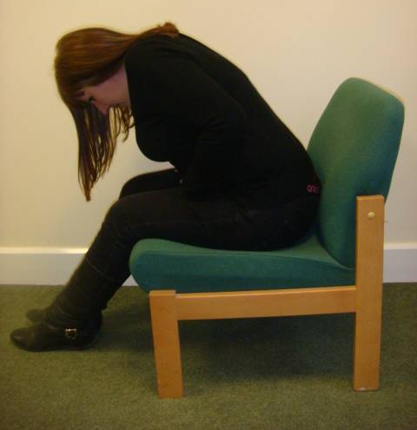

Basket Type Holds

Basket type holds are HIGH RISK. A basket-type hold is any hold where adult arms, the student’s own arms or their clothing is held in a way that could restrict the free movement of the abdomen, diaphragm and chest. Factors such as height, weight, obesity, breathing difficulties and heart conditions could increase the risk.

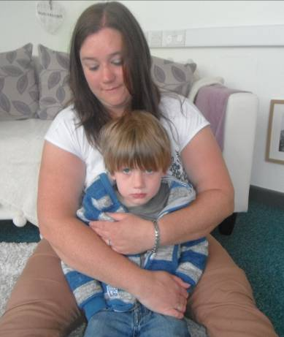

Pulling and Dragging

The dangers of pulling and dragging young children are well documented, as they can lead to dislocation of joints.
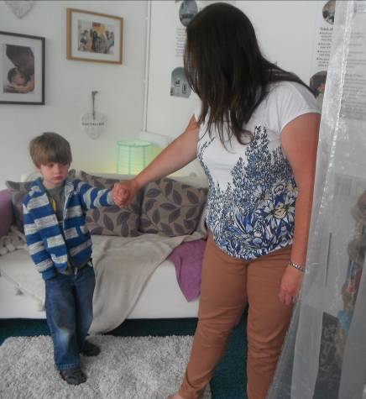

Elevated risk

The following can all result in significant injury:
- Forcing a student up or down steps or stairs
- Dragging a student from a confined space
- Lifting and carrying (including young students capable of walking)
- Seclusion, where a person is forced to spend time alone against their will (requires a court order except in an emergency)

11. Physical Intervention

Physical intervention should be in the student’s best interest and should be conscious of the need to differentiate the attachment to staff from the attachment to key adults such as parents and siblings.

Regardless of age, physical intervention should not provide intimacy within a transient relationship.

Open mitten – Used to move a student away

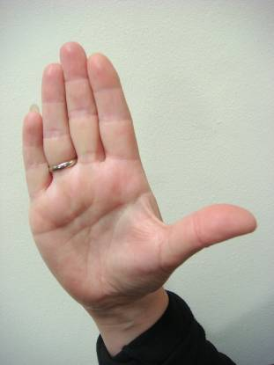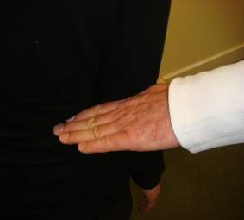

- Fingers together
- Thumb away from fingers
- Palms parallel to floor
- The hand should remain in a mitten to avoid the possibility of gripping. Gripping hands can result in bruising consistent with poor practice

Closed mitten(used to draw a student close)

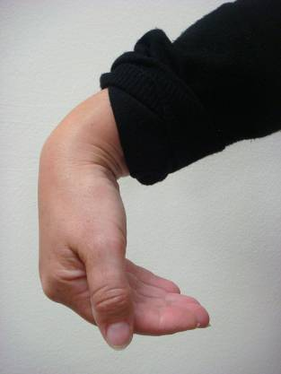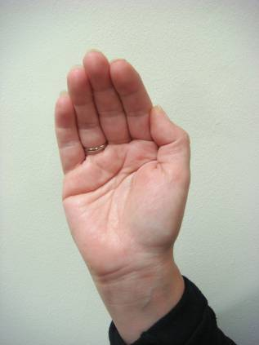

- Flat hand
- Fingers and thumb together
- The hand should remain in a mitten to avoid the possibility of gripping. Gripping hands can result in bruising consistent with poor practice

Offering an arm

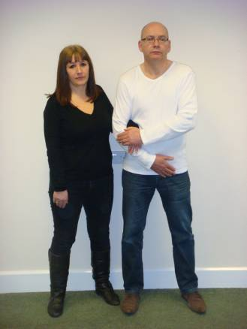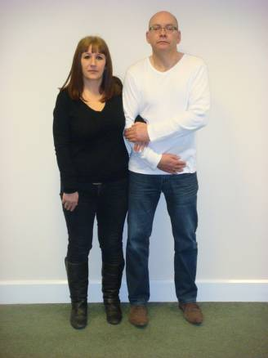

- Hip in
- Head away
- Sideways stance
- Arm is offered
- Student accepts the invite
- Draw elbow in for extra security

Supportive hug (School Hug)

This should be referred to as a school hug, and children and staff should be encouraged to refer to it as such. If a child seeks a hug from school staff then staff should guide children into a ‘School Hug’ nursery children should be encouraged to use this hug rather than being held by staff. Lap sitting should be discouraged in the same way and children moved into a school hug.

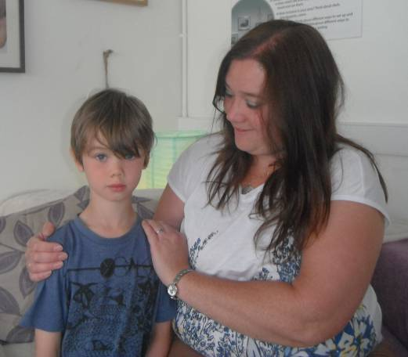

To communicate comfort or reward:
- Hip in
- Head away
- Sideways stance
- Closed mittens contain each shoulder
- Communicate intention
- Use ‘de-escalation script’ if needed

Supportive Arm

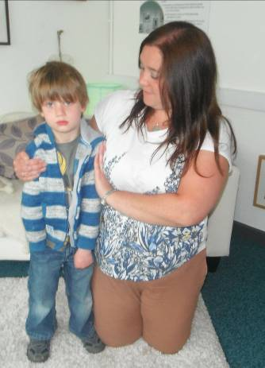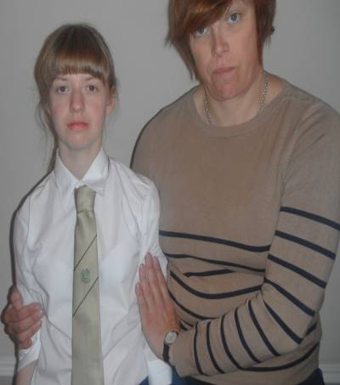

- Hip in
- Head away
- Sideways stance
- Positioned behind the elbow
- Closed mittens used above the elbows to maintain safe shape (penguin shape)
- Communicate intention

Open mitten guide
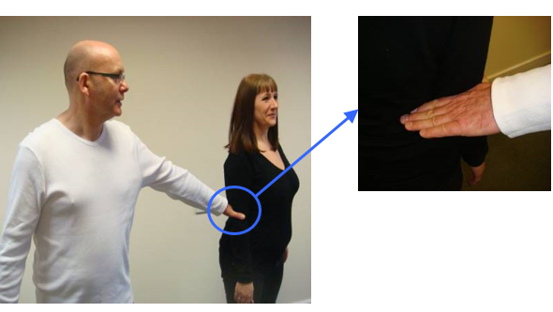

- Open mitten hand, placed on the arm above the elbow
- Safe shape (penguin shape)
- Palm parallel to the floor
- Staff positioned behind with extended arm
- Communicate intention
- Use ‘de-escalation script’ if needed

Open mitten escort

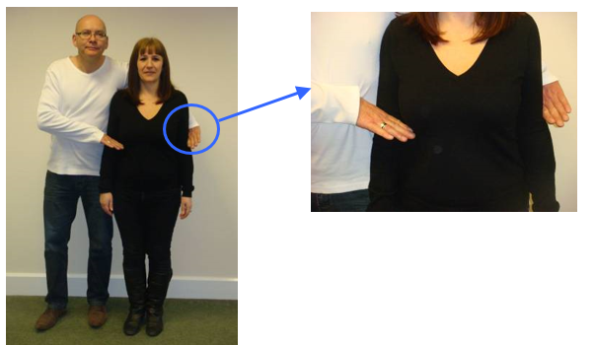

- Hip in
- Head away
- Open mitten hands above the elbows
- Safe shape (penguin shape)
- Arm resting across the shoulders
- Communicate intention
- Move assertively (prevent kicking / dropping)
- The hand should remain in a mitten to avoid the possibility of gripping. Gripping hands can result in bruising consistent with poor practice.

Open mitten escort – paired

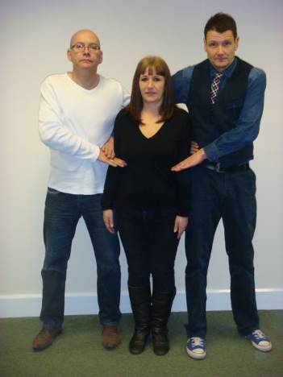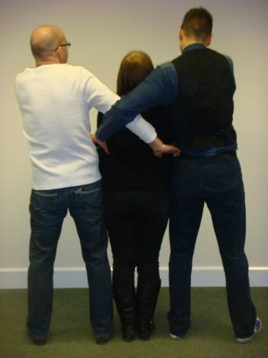

- Hip in
- Head away
- Open mitten hands above the elbows
- Safe shape (penguin shape)
- Arms resting across the shoulders
- Communicate intention
- Move assertively (prevent kicking / dropping)
- The hand should remain in a mitten to avoid the possibility of gripping. Gripping hands can result in bruising consistent with poor practice.

Students who are allowed to plant their feet may choose to drop or kick or spit at staff. Keeping the feet occupied with movement occupies the brain and reduces the disruptive options.
If the student digs their feet in resist the temptation to oppose the force, relax, give a little and the student will reduce resistance.

Remember the desired outcome is SAFETY NOT DESTINATION.

12. Complaints

It is intended that by adopting this policy and keeping parents and governors informed we can avoid or minimise the likelihood of any complaints being made. All disputes which arise about the use of force by a member of staff will be dealt with according to Child Protection and Safeguarding policies, including Whistleblowing.

Appendix
Roots and Fruits
Name
Supporting Staff
Date
Review Date
Pro- social behaviours
Anti-social / difficult / dangerous Behaviours

DEFAULT

Pro-social / positive experiences
Anti-social / negative Experiences
Pro-social / positive feelings
Anti-social / negative feelings

Appendix
Risk Assessment and Reduction Plan: From Steps
Risk Assessment Calculator

Name
DOB
Date of Assessment

Harm/Behaviour | Opinion  Evidenced  O/E | Conscious  Sub-conscious  C/S | Seriousness  Of Harm  A  1/2/3/4 | Probability  Of Harm  B  1/2/3/4 | Severity Risk  Score  A x B
Harm to self

Harm to peers

Harm to staff

Damage to property

Harm from disruption

Criminal offence

Harm from absconding

Seriousness

1 | Evidence of upset or disruption
2 | Evidence of needing support internally from our resources e.g. first aid, nurture, budget allocation
3 | Evidence of needing intervention from external agencies outside of school resources –e.g. hospital, professional counselling or group work, insurance claim
4 | Evidence of harm that cannot be resolved – e.g. loss of life, sectioned mental health, loss through arson
Probability

1 | Yearly or less. No identified triggers remain. There is evidence of historical risk and no evidence of current risk
2 | Monthly or less, the risk is reducing but remains relevant, the context has changed to make a reoccurrence less likely
3 | Weekly or less. The risk of harm is more likely than not to occur again
4 | Daily or constantly. The risk of harm is persistent

Risks which score 6 or more (probability x seriousness) should have strategies listed on next page

Individual Risk Management Plan

Name | DOB | Date | Review Date

Photo | Risk reduction measures and differentiated measures (to respond to triggers)

Pro social / positive behaviour | Strategies to respond
Anxiety / DIFFICULT behaviours | Strategies to respond
Crisis / DANGEROUS behaviours | Strategies to respond
Post incident recovery and debrief measures

Signature of Plan Co-ordinator………………………………… Date ……………….

Signature of Parent / Carer……………………………………… Date ………………

Signature of Young Person………………………………………Date……………….

Signature of Staff Working with Child………………………………… Date ……………….

Signature of Staff Working with Child………………………………… Date ……………….

Signature of Staff Working with Child………………………………… Date ……………….

Signature of Staff Working with Child………………………………… Date ……………….

Appendix

Risk Assessment for Early Years Settings

Name:

Risk Factor:

Potential hazardous | Risk to | Risk to | Procedure
and risky activities | child | others |  | Benefits to
identified |  |  |  | child

Risk Assessment completed by:

Date:

Parent/Carers signature:

Review date:

Appendix G

Physical Intervention Record (record in the bound Blue Book)

Name of Pupil | Date
Staff Involved | Time
Incident number | Duration
Location
Reason for Intervention:

To prevent a pupil from doing or continuing to do any of the following:

Please tick box(es)

- Self harming;
- Causing injury to other children, staff or children;
- Causing damage to property;
- Committing any offence;
- In school settings, any behaviour prejudicial to the maintenance of good order and discipline within the school or among any of its pupils.
____________________________________________________________________
Name of witness/witnesses:

___________________________________________________________
De-escalation Strategies used:

Physical Intervention used:
Single elbow standing | Double elbow | T-Wrap standing
Single elbow seated | Figure of four | T-Wrap seated
Small child escort | Other
___________________________________________________________________
What happened immediately before the incident?

Description of incident (including pupil's response):

Follow up (debrief, accident forms, further action):

Discussion with staff:
Signed Date

Pupil’s comments:

Signed Date

Give details of any injury sustained by persons and/or damage to property:

Was injury reported using Form IRF(96)?

Parent/carer informed?
By letter | Date | By telephone | Date
Home/school diary | Date
Record completed by
Name |  | Signed | Date
Name |  | Signed | Date
Copies to:
Class teacher |  | Headteacher
Pupil file |  | Parent/carer

Appendix H

Recommended Protocol for Child Exiting the Room or Premises Following an Incident

Advice currently given to schools by Steps Tutors and the Local Authority

- Settings should have a plan in place for the member of staff supporting the child or young person to be able to summon assistance and a strategy for notifying a ‘critical friend’ that the child or young person is about to / has exited the building (e.g. red card.)

- Staff should not physically prevent the child leaving the room or building unless there is immediate risk of harm

- Assigned member of staff should follow the child at a safe distance, keeping them in their sight if possible; they should proceed in a calm manner; they should not run or shout to the child or young person. If it is possible to communicate with the child or young person they should use the de-escalation Script.

The script is developed to allow a simple message to be communicated without misunderstanding or provoking an argument. The framework avoids the use of ‘you’ and there is a ‘no blame – no threat’ message throughout. Once the individual child’s needs and difficulties are known the script can be personalised to include the strategies set out in the risk reduction plan (see appendix).

- Back at the setting the ‘critical friend’ should alert the office that the child has left the premises. The receptionist should phone parents and the local police; staff should obtain the number of the local police station, not phone 999. Having passed on the message the ‘critical friend’ should then follow the member of staff supporting the child, collecting a mobile phone or walkie-talkie from the office, if possible. This will enable them to remain in contact with the setting office so parents / police can be informed about the child’s current whereabouts.

- Once the child has returned safely and has had time to calm down a post incident support de-brief should follow (see appendix for an example).

- Following an incident when a child has exited the site a risk reduction plan should be put into place (see appendix). This will help staff to identify the triggers and escalation of behaviours that have resulted in the child running out of the setting and to plan appropriate strategies to intervene at an early stage to divert and offer support to reduce the likelihood of a recurrence of the incident. The risk reduction plan should be drawn up in consultation with parents and all parties should sign on the back to give their agreement.

De-escalation and Diffusion Strategies for Behaviour Management

The schedule below offers a combination of strategies. It offers a staged model for recognising and responding to an escalation of challenging behaviour. It is intended for guidance only as the plan for each individual child / young person should reflect his/her own individual pattern of behaviour, needs and those interventions identified as being successful over time.
This can be used in to help inform the risk reduction plan

Stage 1 Anxiety / trigger

 |  | Low level behaviours may include: |  | Low level staff responses
 |  | Child/young person shows signs of anxiety |  |  |  | Read the body language
 |  | Hiding face in hands or bent over / under table |  |  |  | Read the behaviour
 |  | Pulling up collar or hood |  |  |  | Intervene early
 |  |  | Rocking or tapping |  |  | Communicate – offer help
 |  |  | Withdrawing from group |  |  | Use appropriate humour
 |  | Refusing to speak or dismissive |  |  |  | Display calm body language
 |  |  | Refusing to co-operate |  |  | Talk low, slow and quietly
 |  |  | Adopting defensive positions |  |  | Offer reassurance – including positive physical
 |  |  |  |  |  | prompts
 |  |  |  |  |  | Assess the situation and consider the
 |  |  |  |  |  | environment
 |  |  |  |  |  | Divert and distract by introducing another activity
 |  |  |  |  |  | or topic
 |  | Stage 2 Defensive / escalation
 |  | Medium level behaviours may include: |  | Medium level staff responses
 |  | Child/young person begins to display higher |  |  |  | Continue to use Stage 1 responses
 |  |  | tension |  |  | State desired behaviours clearly
 |  |  | Belligerent and abusive |  |  | Set clear enforceable limits
 |  | Making personal and offensive remarks
 |  |  |  |  |  | Offer alternatives and options
 |  | Talking louder – higher – quicker
 |  |  |  |  |  | Offer clear choices
 |  |  | Adopting aggressive postures
 |  |  |  |  |  | Give a get out with dignity
 |  | Changes in eye contact
 |  |  | Pacing around |  |  | Assess the situation and consider making
 |  |  | Breaking minor rules |  |  | changes to the environment to make it safer and
 |  |  | Low level destruction |  |  | to summon help
 |  | Picking up objects which could be used as |  |  |  | Guide the child/young person towards safety
 |  |  | weapons
 |  | Challenges – ‘I will not … you can’t make me’
 |  | Stage 3 Crisis
 |  | High level behaviours may include: |  | High level staff responses
 |  |  | Shouting and screaming |  |  | Continue to use Stage 1 & 2 responses
 |  |  | Uncontrollable crying |  |  | Make the environment safer
 |  |  | Damaging property |  |  | Move furniture and remove weapon objects
 |  |  | Moving towards danger |  |  | Guide assertively – hold or restrain if absolutely
 |  | Climbing trees, roofs or out of windows |  |  |  | necessary
 |  | Banging on or threatening to break glass |  |  |  | Ensure face, voice and posture are supportive not
Use of objects as weapons |  |  |  |  | aggressive
Hurting self |  |  |  | Send for help / consider change of personnel to
Grabbing or threatening others |  |  |  |  | defuse situation, if possible and appropriate
Hurting others (kicking – slapping – punching) |  |  |  | Consider making changes to the environment to
 |  |  |  |  | defuse and de-escalate
Stage 4 Recovery
Recovery behaviours may include: |  |  |  | Staff recovery responses
Please note the recovery phase can easily be
confused with the anxiety phase
Child/young person may sit quietly in hunched |  |  |  |  | Support and monitor
position |  |  |  | This may not be a good time to touch as touch at
The difference is that they may revert to extreme |  |  |  |  | this phase can provoke a reversion to crisis
anger without the build up associated with the |  |  |  |  | Give space
normal escalation in stage 2 |  |  |  | Look for signs that child/young person is ready to
 |  |  |  |  | talk
 |  |  |  |  | Consider the environment
Stage 5 Depression
Depression behaviours |  |  |  | Staff responses to depression
After a serious incident child/young person can |  |  |  |  | Support and monitor
become depressed |  |  |  | Respond to any signs that the child/young person
They may not want to interact but need support |  |  |  |  | wants to communicate
and reassurance |  |  |  | Show concern and care but do not attempt to
 |  |  |  |  | address consequences of the incident at this
 |  |  |  |  | stage
Stage 6 Follow up
Listening and learning |  |  |  | Staff responses during and following debrief
 |  |  |  | When the child/young person has had time to
 |  |  |  |  | calm down find a quiet neutral place in which to
 |  |  |  |  | meet with the child/young person to debrief
 |  |  |  | Follow up any disciplinary or restorative issues
 |  |  |  | Review Risk Reduction / Care Plan to consider
 |  |  |  |  | how to avoid similar events in the future
 |  |  |  | Communicate with child/young person in manner
 |  |  |  |  | appropriate to their age, understanding and
 |  |  |  |  | development
 |  |  |  | Report, record and review

Appendix Anxiety Mapping
+4
Time / Location / Staff / Activity / Learning Style / ETC
0
-4
-2
-3
-1
+1
+2
+3
Anxiety

Appendix De-escalation Script

- Learner’s name

- I can see something has happened

- I am here to help

- Talk and I will listen

- Come with me and……..

