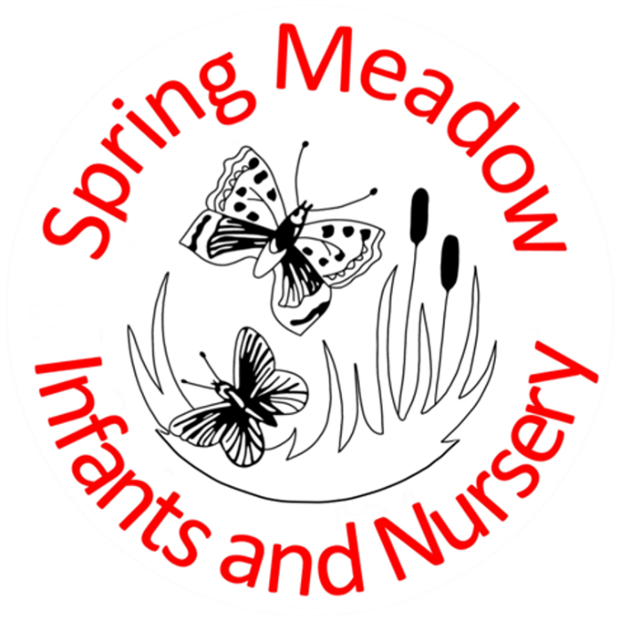
Supporting pupils with medical conditions policy
Lead author/initiator(s): | Laura Fielding
Next Review Date: | February 2025
Ratified by: | Spring Meadow Infant and Nursery Resources Committee
Date Ratified: | 24th January 2024
Review Timetable: | Annually

This policy was written in line with the requirements of:
- Children and Families Act 2014 – section 100
- Supporting pupils at school with medical conditions: statutory guidance for governing bodies of maintained schools and proprietors of academies in England, DFE Sept 2014
- Mental Health and behaviour in schools: departmental advice for school staff, DfE June 2014
- Equalities Act 2010
- Schools Admissions Code, DfE 1 Feb 2010
This policy should be read in conjunction with the following school policies SEN policy, Safeguarding policy, First Aid policy, Intimate Care policy, Asthma policy, Attendance policy, Accessibility Plan and Complaints policy.
Definitions of Medical Conditions
Pupil’s needs may be broadly summarised as being of two types:
Short term affecting their participation at school because they are on a course of medication
Long term potentially limiting access to education and requiring on-going support, medicines or care while at school to help them to manage their condition and keep them well, including monitoring and intervention in emergency circumstances. It is important that parents feel confident that the school will provide effective support for their child’s medical condition and that pupils feel safe.
Some children with medical conditions may be considered disabled. Where this is the case governing bodies must comply with their duties under the Equality Act 2010. Some may also have Special Educational Needs (SEN) and may have a statement or Education, Health and Care Plan (EHCP). Where this is the case this policy should be read in conjunction with the 0-25 SEND Code of Practice and the school’s SEN Policy and the individual healthcare plan will become part of the EHCP.
Policy Implementation
The statutory duty for making arrangements for supporting pupils at school with medical conditions rests with the governing body. The governing body have conferred the following functions of the implementation of this policy to the staff below, however, the governing body remains legally responsible and accountable for fulfilling our statutory duty.
The overall responsibility for the implementation of this policy is given to the Headteacher, who is also responsible for ensuring that sufficient staff are suitably trained and will ensure cover arrangements in cases of staff absences or staff turnover to ensure that someone is always available and on site with an appropriate level of training. The Headteacher will be responsible for briefing supply teachers. The headteacher will be responsible for ensuring that risk assessments for school visits and other school activities outside of the normal timetable are carried out by the trip organiser. The headteacher will also be responsible for the monitoring of individual healthcare plans and will be responsible in conjunction with parents/carers for drawing up, implementing and keeping under review the individual healthcare plan for each pupil and making sure relevant staff are aware of these plans.
All members of staff are expected to show a commitment and awareness of children’s medical conditions and the expectations of this policy. All new members of staff will be inducted into the arrangements and guidelines in this policy upon taking up their post.

Procedure to be followed when notification is received that a pupil has a medical condition (transition)
This covers notification prior to admissions, procedures to cover transitional arrangements between schools or alternative providers, and the process to be followed upon reintegration after a period of absence or when pupils’ needs change. For children being admitted to Spring Meadow Infant and Nursery School for the first time, with good notification given, the arrangements will be in place for the start of the school term. In other cases, such as a new diagnosis or a child moving school mid-term, we will make every effort to ensure that arrangements are put in place within three weeks. In making arrangements, we acknowledge that many medical conditions that require support at school will affect quality of life. We will ensure that the focus of these arrangements is the need of the individual child and how their medical condition impacts upon their school life. We aim to ensure that parents/carers and pupils can have confidence in our ability to provide effective support for medical conditions in school, so the arrangements will show an understanding of how medical conditions impact on the child’s ability to learn, as well as increase their confidence and promote self-care.
We will ensure that staff are properly trained and supervised to support pupils’ medical conditions and will be clear about the need to actively support pupils with medical conditions to participate in school trips and visits, or in sporting activities. We will make sure that no child with a medical condition is denied admission or prevented from attending the school because arrangements for supporting their medical condition have not been made.
Spring Meadow Infant and Nursery School does not have to wait for a formal diagnosis before providing support to pupils. In cases where a pupil’s medical condition is unclear, or where there is a difference of opinion, judgements will be needed about what support to provide based on available evidence. This would normally involve some form of medical evidence and consultation with parents/carers. Where evidence conflicts, some degree of challenge may be necessary to ensure that the right support can be put in place. This consultation will be arranged by the headteacher, following this an individual health care plan will be written in conjunction with the health care professionals involved and signed by parents/carers.
What happens if a pupil is absent from school due to their medical condition?
Pupils should not be penalised if their absence from school is related to their medical condition, such as attending hospital appointments. In order to avoid being fined for non-attendance, parents must obtain permission from the school in advance of the appointment, so that the absence can be treated as authorised. An absence can also be authorised if the child is too ill to attend school and the school is notified of that as soon as possible. For more information on non-attendance, please refer to our School attendance policy. Where a child with a life limiting condition receives care from a hospice the school recognises the benefits this can bring the whole family, therefore hospice stays will be considered an authorised absence.
If the pupil’s absence is expected to be for more than 15 days, the Local Authority is under a duty to ensure that the child receives as normal an education as possible while he or she is absent. The Local Authority must start arranging the education from the 1st day that the school receives notice of the length of absence. A senior officer from the Local Authority must be appointed, to oversee the arrangements and provide a written statement to the parents on how the education will be delivered. A range of options can include home teaching, a hospital school or teaching service, or a combination of those options. A full-time education should be provided unless part-time education is more suitable for the child’s health needs.

The school will work closely with those involved in the care of a pupil to decide what work a child who is off for less than 15 days needs. The school will usually consider that if a child is too unwell to attend then providing school work should not be necessary. However where it is in the best interests of the child then parents may wish to select additional reading books and arrange for school work to be sent home and returned to school for marking. The school will use Teams try to maintain contact with children who are off for longer than a week.
Individual Healthcare Plans
Individual Healthcare plans will help to ensure that the school and pre-school effectively supports pupils with medical conditions. They will identify what needs to be done, when and by whom.
A flowchart for identifying and agreeing the support a child needs and developing an individual healthcare plan is provided in Appendix 1.
Individual healthcare plans will be easily accessible to all who need to refer to them while preserving confidentiality. The level of detail within the plan will depend on the complexity of the child’s condition and the degree of support needed. Where a child has SEN but does not have a statement or EHCP their special educational needs should be mentioned in their individual healthcare plan.
Individual healthcare plans should be drawn up in partnership between the school, parents/carers and a relevant healthcare professional. Responsibility for ensuring it is finalised and implemented rests with the school. The school and pre-school will ensure that individual health care plans are reviewed at least annually or earlier if necessary.
Appendix 2 is a basic template for an individual healthcare plan but they should all contain the following information:
- The medical condition, its triggers, signs, symptoms and treatments.
- The pupil’s resulting needs, including medication (dose, side effects and storage) and other treatments, time, facilities, equipment, testing, access to food and drink, dietary requirements and environmental issues.
- Specific support for the pupil’s educational, social and emotional needs (how absences will be managed, requirements for extra time, rest periods)
- The level of support needed.
- Who will provide the support, their training needs, expectations of their role and cover arrangements if they are unavailable.
- Who in school needs to be aware of the child’s condition and the support required.
- Arrangements for written permission from parents/carers for medication to be administered by a member of staff or self-administered by the pupil during school hours.
- Separate arrangements or procedures required for school trips or other school activities outside of the normal timetable, ie risk assessment.
- What to do in an emergency, including whom to contact and contingency arrangements.
Parents/carers
They should provide the school with sufficient and up to date information about their child’s medical needs. They should carry out any action they have agreed to in the individual healthcare plan, eg provide medicines and equipment and ensure they or another nominated adult are contactable at all times.

Local Authority
Where a child is not able to attend mainstream school because of their health needs the local authority has a responsibility to make other arrangements. This is when a child is away from school for 15 days or more.
Staff training and support
All staff who are required to provide support to pupils for medical conditions will be trained by healthcare professionals qualified to do so. The training will be identified by the healthcare professional during the development or review of the plan. Training should be sufficient to ensure that staff are competent and have confidence in their ability to support pupils with medical conditions and to fulfil the requirements set out in the individual healthcare plans. They will need an understanding of the specific medical conditions they are being asked to deal with, their implications and preventative measures.
All staff will receive induction training and whole school awareness training so they are aware of the school’s policy for supporting pupils with medical conditions and their role.
The child’s role in managing their own medical needs
If, after discussion with the parent/carer it is agreed that the child is competent to manage his/her own medication and procedures, he/she will be encouraged to do so. This will be reflected in the individual healthcare plan.
If a child self-manages they may still require a level of supervision and if it is not possible for them to self-manage then relevant staff will help to administer and manage the procedures for them.
If a child refuses to take medicine or carry out a necessary procedure, staff should not force them to do so, but follow the procedure agreed in the individual healthcare plan. Parents will be informed immediately so that alternative options can be considered.
Managing medicines on school premises and record keeping
At Spring Meadow Infant and Nursery School the following procedures are to be followed:
- Medicines should only be administered at school when it would be detrimental to a child’s health or school attendance not to do so.
- School will not store or administer medicines that have not been prescribed to a child, unless the bullet point above applies. (Please make arrangements to come into school if you wish to give your child these medicines).
- In line with other school policies, if medicines are prescribed up to 3 times a day, the expectation is that parents/carers will give these medicines outside of school hours.
- If medicines are prescribed 4 times a day, parents/carers are strongly encouraged to make arrangements to come in and administer these.
- If the school agrees to administer medicines to a child the parents/carers must provide the medicine in its original container and have the label showing:
- Name of child:
- Name of medicine:
- Method of administration:
- The instruction leaflet with prescribed medicines should show:
- Any side effects
- Expiry date

The school will provide blank medicine record forms (See end of policy) and parents/carers must complete and sign one of these forms if they leave medicine at school.
Emergency Procedures
The headteacher will ensure that arrangements are in place for dealing with emergencies for all school activities wherever they take place.
Where a child has an individual healthcare plan this should define what constitutes an emergency and explain what to do, ensuring that all relevant staff are aware of emergency symptoms and procedures. If a child needs to be taken to hospital, staff should stay with the child until the parent arrives or accompany a child taken to hospital by ambulance.
Day Trips, Residential Visits and Sporting Activities
Children with medical conditions will be actively supported to participate in day trips, residential visits and sporting activities unless there is evidence from a clinician that this is not possible.
A risk assessment will take place to ensure that pupils with a medical condition can be included safely. This will involve consultation with parents/carers, relevant health care staff and informed by HSE guidance on school trips.
Unacceptable Practice
Staff at Spring Meadow Infant and Nursery School should use their discretion and judge each case on its merits with reference to the child’s individual healthcare plan. It is not generally acceptable practice to:
- Prevent children from easily accessing their inhalers and medication and administering their medication when and where necessary.
- Assume that every child with the same condition requires the same treatment.
- Ignore the view of the child or their parents/carers or ignore medical evidence or opinion (although this may be challenged).
- Send children with medical conditions home frequently or prevent them from staying for normal school activities, including lunch, unless this is specified in their individual healthcare plans.
- If the child becomes ill send them to the first aid area/office unaccompanied.
- Penalise children for their attendance record if their absences are related to their medical condition, ie hospital appointments.
- Prevent pupils from drinking, eating or taking toilet breaks whenever they need to in order to manage their medical condition effectively.
- Require parents/carers or otherwise make them feel obliged, to attend school to administer medication or provide medical support to their child, including with toileting issues. No parents should have to give up working because the school is failing to support their child’s medical needs.
- Prevent children from participating, or creating unnecessary barriers to children participating in any aspect of school life, including trips

Complaints
Should parents/carers be unhappy with any aspect of their child’s medical care at school they must discuss their concerns with the school. This will be the Class teacher in the first instance. If this does not resolve the problem then the headteacher should be informed. If this does not resolve the issues then the parent/carer must make a formal complaint using the Spring Meadow Infant and Nursery School Complaints Procedure.

Appendix 1

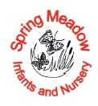
Individual healthcare plan template

Name of school/setting | Spring Meadow Infant and Nursery School
Child’s name
Group/class/form
Date of birth
Child’s address
Medical diagnosis or condition
Date
Review date
Family Contact Information
Name
Phone no. (work)
(home)
(mobile)
Name
Relationship to child
Phone no. (work)
(home)
(mobile)
Clinic/Hospital Contact
Name
Phone no.
Name
Phone no.

Who is responsible for providing support in school

Describe medical needs and give details of child’s symptoms, triggers, signs, treatments, facilities, equipment or devices, environmental issues etc
Name of medication, dose, method of administration, when to be taken, side effects, contra-indications, administered by/self-administered with/without supervision
Daily care requirements
Specific support for the pupil’s educational, social and emotional needs
Arrangements for school visits/trips etc
Other information
Describe what constitutes an emergency, and the action to take if this occurs
Who is responsible in an emergency (state if different for off-site activities)
Plan developed with

Staff training needed/undertaken – who, what, when
Form copied to

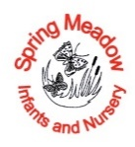
Parental agreement for Spring Meadow Infant and Nursery School to administer prescribed medicine
The school will not give your child medicine unless this form is completed and signed. Parents/carers must provide the medicine in its original container and must have been dispensed by a pharmacist and have the label showing:
- Name of child:
- Name of medicine:
- Method of administration:
- The instruction leaflet with prescribed medicines should show:
- Any side effects
- Expiry date
Date for review to be initiated by
Name of school/setting
Name of child
Date of birth
Group/class
Medical condition or illness
Name/type of medicine
(as described on the container)
Expiry date
Dosage and method
Quantity received by school
Timing
Special precautions/other instructions e.g. storage
Are there any side effects that the school/setting needs to know about?
Self-administration – y/n
Procedures to take in an emergency
Quantity returned |  |  |  | Date:
NB: Medicines must be in the original container as dispensed by the pharmacy

Contact Details
Name
Daytime telephone no.
Relationship to child
Address
I understand that I must deliver the medicine personally to | [agreed member of staff]

The above information is, to the best of my knowledge, accurate at the time of writing and I give consent to school/setting staff administering medicine in accordance with the school/setting policy. I will inform the school/setting immediately, in writing, if there is any change in dosage or frequency of the medication or if the medicine is stopped.

Name Signature(s)
Date

Recepit of medication confirmed by:
Date medicine provided by parent
Quantity received |  |  |  |  | Date
Witness by (in case of controlled drugs) |  |  |  |  | Date
Name and strength of medicine
Expiry date
Dose and frequency of medicine
Quantity returned to parent |  |  |  |  | Date

Authorisation to administer medication approved by headteacher (or senior teacher)

Name Role

Signature Date

Spring Meadow Infant and Nursery School
Record of medicine administered

Child’s name

Date  00/00/00 | Time | Name of medicine | Dose given | Any reactions | Signature | Print name of staff | Witness Signature(controlled drugs)

