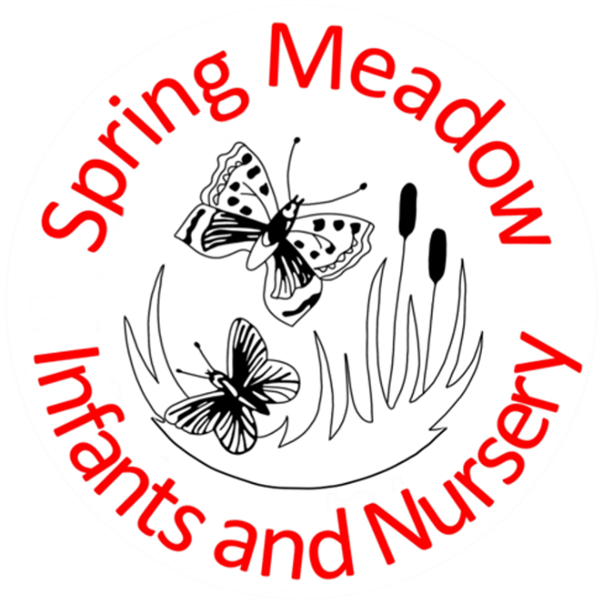
Behaviour Policy

February 2024

Lead author/initiator(s): | Laura Fielding (Headteacher)
Next Review Date: | February 2026
Version No: | 3
Ratified by: | Spring Meadow Infant and Nursery School Local Governing Body
Date Ratified: | 8.2.2024
Review Timetable: | Review bi-annually

Spring Meadow Infant and Nursery School Behaviour Policy

Contents:
- School Ethos
- Rationale
- Aims for Behaviour at Spring Meadow
- Roles and Responsibilities
- The Curriculum
- Praise, Reward and Celebration
- Consequence and Sanctions
- Behaviour Management Protocol
- Reasonable Force
- Reporting
- Parental Involvment

School Ethos

At Spring Meadow Infant and Nursery school, we have the following core values:
Kind | For everyone to show kindness as they work, play and learn. Everyone is treated with mutual respect.
Independent | To be independent learners who take responsibility for themselves. The school provides an environment which enables them to make decisions and choices to reach their full potential.
Inclusive | To include everyone in our school and wider community and to embrace and celebrate everyone’s individual special qualities.
Resilient | Everyone is resilient to take risks, try new things and learn from their mistakes.
Creative | As a school we nurture an environment where there is freedom to express individual ideas, use our imagination and be inspired to be creative across the curriculum.
Knowledgeable | To be knowledgeable about the community and the world around us. The children build on their previous knowledge. The curriculum is delivered using approaches which enable the children to know more and remember more.

These values are embedded across all aspects of the school to ensure a culture of positivity and inclusivity.

Rationale

This policy outlines our approach to behaviour management throughout the school. It is recognised that appropriate behaviour is a pre-requisite to effective teaching and learning. Our philosophy is research-based and interwoven with the school’s ethos.

Aims for Behaviour at Spring Meadow

- For children and adults to be ready to learn, engage and consider the needs of others.
- To teach and expect respect for individuals, the school and its property, adhering to our values and ethos.
- For children and adults to keep themselves and others safe.

Roles and Responsibilities

It is the responsibility of all members of a school community to develop prosocial behaviour. Staff are expected to lead by example and support each other in promoting high quality interactions with others.

The role of adults (including staff, parents, governors and community visitors)
- To promote an awareness of everybody’s individual needs.
- To model pro-social behaviour and take pride in their school, their class, their work, their environment and their relationships with others.
- To treat children fairly, consistently and sensitively, demonstrating visible kindness.
- To celebrate and praise children’s achievements, successes and efforts.
- To collaborate effectively to find solutions to antisocial behaviour.
- To actively teach children about prosocial behaviour.
The role of children
- Be ready to learn.
- To show respect to other people and the school environment, acting in line with the school’s values.
- To behave in a prosocial way so that they keep themselves and others safe.

The Curriculum

We teach children how to behave in a prosocial manner through modelling, positive praise and direct teaching. Pupils are encouraged to participate actively in PSHE, PE and RE lessons as well as daily assemblies, all of which embed the school’s core values and ethos.

Staff are encouraged to create well-ordered and inviting learning environments that are conducive to high quality learning for all pupils. Playground staff promote a variety of activities so that team work, co-operation, fair play and sportsmanship are encouraged.

Praise, Reward and Celebration

We believe that learners should be praised for demonstrating prosocial behaviour in school. There are a number of ways to do this including:

- Recognition boards
Children’s names are displayed on a classroom board to show that they are following the school’s rules.
- Celebration assembly
Each week an assembly is held to celebrate children’s achievements. Classroom staff decide upon a ‘star of the week’ and this child is presented with a Headteacher sticker and their name is added to the whole school’s ‘Recognition Board’.
- Stickers
Children will receive stickers with specific praise for how they have followed the school rules or demonstrated one of the school values. This must not be used to bribe the children and should not be expected by children. We follow a ‘Catch them doing something good’ approach.
- Positive Praise
Children will receive positive praise from adults when they are caught following the school rules and demonstrating the school values.

Consequences and Sanctions

We follow the Cambridgeshire steps programme which aims to recognise pro and antisocial behaviour, emphasising the need to reflect, repair and restore.
Staff are trained to recognise the degree of seriousness and the kind of behaviour consequences that should be used. They must ensure that the consequences are reasonable, proportionate and necessary to adhere to the school rules of ‘Be Ready, Be Respectful, Be Safe’.
There are two types of consequences:
- Educational Consequences
The goal for this is to stop a child’s antisocial behaviour and support them in making prosocial choices. This involves helping to teach the child to learn from their behaviour.
Example: Child running down the corridor is asked to come back and walk down the corridor at break.
- Protective Consequences
The goal is to protect and therefore keep everyone safe including the child.
Example: Child has break at a different time to their peers as has shown extreme antisocial behaviour.

Sometimes, more serious, or persistent antisocial behaviours need to be addressed by members of the Senior Leadership Team and / or the SENDCo. After any consequence has been issued, there is an expectation that the member of staff who witnessed the behaviour will work with the child, offering them an opportunity to repair and restore their relationship with peers and / or staff involved by having a restorative discussion with the child and completing a comic strip conversation where is appropriate.

Behaviour Management Protocol

When a child is not demonstrating prosocial behaviour, staff will manage each situation as discreetly as they can so as not to cause embarrassment to the child. Staff aim to use few words when talking to the child, making them aware of the pro-social behaviour they should be demonstrating. It is the responsibility of the class teacher to manage behaviour.
In class, staff will:
  - observe the antisocial behaviour
  - use tactical ignoring and / or distraction techniques
  - check the task set and alter the activity if needed
  - work alongside the child briefly, using positive reinforcement methods
  - consider whether the behaviour is difficult or dangerous.
In outdoor areas, staff will:
- observe the antisocial behaviour
- use tactical ignoring and / or distraction techniques
- ask the child to change activity to work with an alternative group or within a different zone of the playground
- walk alongside the child, briefly speaking to them about prosocial behaviour choices
- consider whether the behaviour is difficult or dangerous.

If the antisocial behaviour continues, the staff will make a decision based on their professional judgement as to whether it constitutes difficult or dangerous behaviour.

Examples of difficult behaviour: Putting their equipment down, refusing to start their work, rocking on their chair, poking peers, going under the table, putting equipment in their mouth, shouting out, refusing to share equipment, refusing to come into class, struggling to transition to the next topic, wandering around.

Difficult behaviour includes high anxiety behaviours, where there is not imminent danger such as swearing, pushing, kicking, spitting, shouting and throwing objects.

Dangerous behaviour: Where someone or something is in imminent danger.
This will lead to an appropriate pathway of support and intervention:

Difficult Behaviour: | Dangerous Behaviour:
1. Remind and refocus.  2. Give the pupil limited choices (“this or this”).  3. Temporary removal from the activity (quick job / distraction).  4. Move pupil within the class.  5. Discuss possible consequences.  6. Send pupil to a partner teacher’s classroom with work (refocus on return with positive reinforcement).  7. Comic strip conversation completed with class teacher and pupil. | 1. Teacher to use the de-escalation script (SLT member on call if needed).  2. Provide a supportive environment for the pupil to calm.  3. Ensure other pupils are safe.  4. Once calm, undertake Comic strip conversation with the pupils involved.  5. SLT member to review the incident with staff involved and determine consequences together.  6. Teacher to ensure educational and protective consequences are followed through.  7. Teacher to debrief with SLT.  8. Teacher or SLT member to inform the parent/carer of the incident and measure put into place to help their child learn.  9. Incident form to be completed by all adults involved on the same day.

- Reasonable Force
We are a STEPS school, therefore all adults in school should be using the STEPS strategies, which should mean there should be no need to use force on a child. The Department for Education recognises that in some situations, reasonable force is needed to keep children and staff safe. They have a clear definition on what reasonable force is and when / why it should be used. If any force is used on a child the Headteacher should be informed immediately and it should be logged in the restraint book and an incident form should be completed on the same day.

In addition to the Cambridgeshire Steps Training 6 members of the staffing team have been Team Teach Trained. This is an evidence based training which puts the pupil at the centre of every decision. It provides the 6 members of staff with the confidence and strategies they need to de-escalate situation and reduce physical intervention. When de-escalation has not been successful the training has provided staff with guides and restraints to be used. If this occurs this will then be written in to the children Risk Reduction Plan.
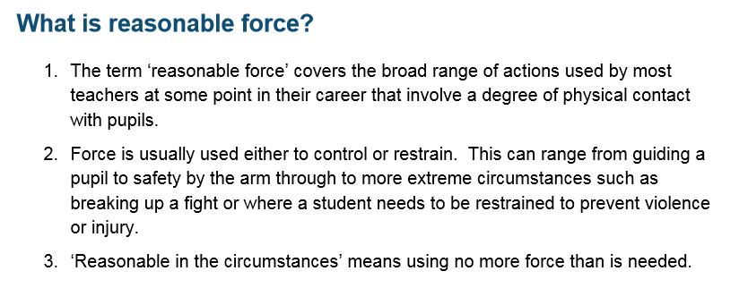

- Reporting
Both prosocial and antisocial behaviour will be recorded. A copy of all comic strip conversations to be given to be given to the Assistant Headteacher for monitoring. Teachers should keep a record of all comic strip conversations to inform their teaching.

- Parental Involvement
As a school we understand the importance of the partnership and communication with parents and therefore we will communicate with parents about the behaviour of their child. If a Comic strip conversation has been completed for unsafe behaviour parents will be informed at the end of the day. If antisocial behaviour continues and more than 5 Comic strip conversations have been completed in a Half Term the teacher will meet informally with parents to discuss support strategies. If a further 3 Comic strip conversations have been completed or there has been dangerous behaviour parents will meet with Class Teacher and a member of SLT and/or SENDCO.

The behaviour policy will be shared with parents annually.

Appendix 1

De-escalation Script

- Learner’s name

- I can see something has happened

- I am here to help

- Talk and I will listen

- Come with me and…….

Appendix 2

Examples of Educational consequences

Behaviour | Rule broken | Educational consequence
Continuous shouting out | Ready | Child to create a poster about good listening
Running in the corridor | Safe | Child to practice walking in the corridor
Not completing work | Ready | Child to complete work at break time and have discussion about good learning with adult
Saying unkind words to another child | Respect | Child to write down what being a kind friend looks like
Shouting at an adult | Respect | Child to draw a picture of a child being respectful to an adult
Not sitting on the carpet/ chair appropriately during the input | Ready | Child to practice sitting and/ or a conversation about why we should sit appropriately and what that would look like

Examples of Protective consequences

Behaviour | Rule broken | Protective consequence
Keeps hurting other children at break | Safe | Child to have a separate break time and not go out with the other children
Child keeps swinging on chair | Safe | Remove chair from child and child sits on the carpet

*Where a protective consequence has been put in place a member of SLT should be informed. A child should not miss their education for a consequence.

Appendix 3
Comic Strip Behaviour Reflection Log
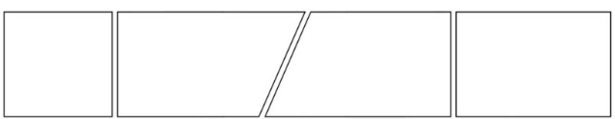
(Draw the response to each question. Include speech bubbles and simple labels)

What happened?

What could you have done instead?

How can you fix it?

Educational/Protective consequences

Prosocial: relating to or denoting behaviour which is positive, helpful, and intended to promote social acceptance and friendship.
Antisocial: unwilling or unable to associate in a normal or friendly way with other people.

