Early Years Foundation Stage policy

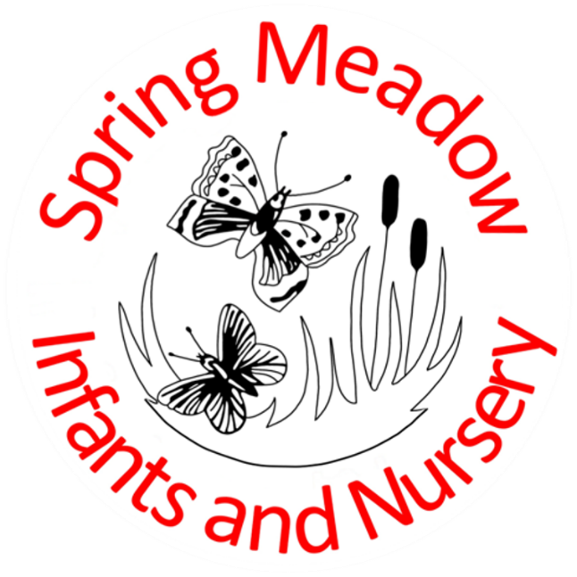

Written by: Claire Tomlin EYFS lead
Date: November 2025
To be reviewed November 2026

Spring Meadow Infant and Nursery School - Our vision and values
At Spring Meadow our children are kind and resilient young people who acquire the skills and knowledge they need to succeed and compete in the diverse world in which they live. They are independent explorers who are curious and proactive, always seeking out answers to new questions and ideas. Their kindness and compassion enable them to live and grow in a safe and considerate world.
In the Early Years we are aspirational as well as inspirational. Challenge is always present and in our safe and secure setting children feel confident to give new things a try. The children are supportive of each other and help their peers to succeed when these challenges present themselves. Our children are wonderful individuals with individual needs and we always ensure these are met and that every child and family feels fully included at all times.
Our EYFS guiding principles
Our early years setting follows the curriculum as outlined in the 2023 statutory framework of the EYFS. There are four guiding principles that shape the practice in our early years settings.
- Every child is a unique child, who is constantly learning and can be brave and resilient, curious and questioning, kind, confident and self-assured from a very young age
- Every child learns to be strong and independent through positive relationships which are nurtured throughout the early years.
- Every child learns and develops well in enabling environments, in which the experiences meet their individual needs and there is a strong partnership between practitioners, parents and carers.
- The EYFS framework covers the education and care of all children in early years’ provision, including children with special educational needs and disabilities, and recognises that children learn and develop differently.

This policy aims to ensure that:
- Leaders provide a curriculum that is ambitious and designed to give all pupils, including disadvantaged pupils and those with SEND, the knowledge and cultural capital they need to succeed in life.
- Consistent use of high-quality assessment, focused planning approaches and high quality teaching and learning ensures every child makes good progress from their starting points.
- We have close working partnerships between practitioners, parents and carers.
- Every child is included and supported through the equality of opportunity we provide.

Curriculum
The EYFS framework includes 7 areas of learning and development that are equally important and inter-connected. However, 3 areas known as the prime areas are seen as particularly important for igniting curiosity and enthusiasm for learning, and for building children’s capacity to learn, form relationships and thrive. The early years curriculum at Spring Meadow teaches key knowledge and skills through these seven areas of learning, and leaders across the school ensure that there is a clear development from Nursery into Reception and beyond.
We follow a planned set of topics from the Primary Knowledge Curriculum which are highly aspirational in terms of both knowledge and vocabulary. The knowledge acquired then inspires curiosity and creativity in the children in order for them to continue their own learning within the environment during COOL time. The selection of high quality English texts in conjunction with the Talk 4 Writing and Talking Through Stories approaches provides a variety of opportunities for expanding and enriching the children’s spoken vocabulary and developing language skills.
Phonics: Nursery activities are provided within seven aspects to support the children with being able to: Listen attentively, enlarge their vocabulary, speak confidently to adults and other children, discriminate phonemes, reproduce audibly the phonemes they hear, in order, all through the word, use sound-talk to segment words into phonemes.
Phonics: Reception The Read Write Inc phonics program is used as a whole school school approach to the teaching of phonics. This ensures consistency for all children and enables good progress from one year group to the next. The children are taught to read and identify letter sounds alongside developing blending skills. Phonics teaching begins from the first day that children begin school at Spring Meadow and continues daily with timetabled lessons. For those children who are not yet ready to join whole class lessons on the carpet, teaching takes place within the provision in a way which supports the child’s individual needs.
Reading: Nursery children are exposed to a wide variety of reading books, both fiction and non-fiction. Teachers use key texts to help drive the topic of the week, key reading areas as well as communication spaces enable children to access books for pleasure throughout their time in nursery. Practitioners model how a reader behaves so children can copy these, key new language is identified and shared with the children to enhance their understanding of new words.
Reading: Reception children continue to access a wide variety of reading books in the environment as well as those linked to the current topic. Children are given reading books which match the phonics teaching so as to practise their blending skills and reading of sight vocabulary. However, the love and joy of reading is the absolutely key essential factor and class teachers work to ensure develop an enjoyment of books, both fiction and non-fiction. Library books are chosen for enjoyment from the school library once a week.
White Rose Maths is the scheme upon which the daily maths teaching is based. Children develop their understanding of numbers and mathematical concepts through engaging, practical teacher led learning opportunities as well as group or 1:1 tasks. The children are provided with opportunities to apply new learning through enhancements in the continuous provision.
Focused teaching and continuous provision supports the learning and development of each area of learning and is situated in a calm and welcoming environment. It is enhanced to reflect the topics and texts being taught and further develop purposeful play linked to the children’s emerging need and interests. Learning Walks introduce adult led challenges and provide the children with opportunities to consider how they can continue their own learning and pursue their own lines of enquiry. Learning Talks with the floor books revisit previous learning to encourage the children to develop ownership of their learning as well as supporting them to make links and remember more. Practitioners support this process by responding to each child’s emerging needs and interests through sustained shared thinking approaches which develop active engagement and concentration.
In addition to the indoor and outdoor provision provided the children also have the opportunity to learn in the Forest School environment through sessions led by Qualified leaders. These sessions provide opportunities for children to develop self-awareness, self-regulation, self-motivation, empathy, and their social skills. These are developed through a variety of activities for example, experiencing seasonal change, cooking on open fires, building dens and shelters and looking for and identifying wildlife

Planning and Assessment
At Spring Meadow Infant and Nursery School, daily assessment is an integral part of the learning and development processes. Staff work hard to develop positive relationships with the children which ensures observations of pupils identify their level of achievement and attainment, interests and learning styles. These observations are used to shape planning, and next steps and are recorded in floor books. Early years staff meet weekly to discuss the needs and achievements of the children and plan the next provision enhancements and provocations needed to continue the children’s development. All staff will have access to plans and can contribute to ‘feeding forward’ planning.
The Two Year Check will be completed for Two year old children in Nursery once they have been in Caterpillar Class for a term, providing that this has not already been completed in an alternative setting. The check will focus on the Prime areas of Learning for the Early Years curriculum and a short report will be written for parents.
Children in Reception undertake the Reception Baseline as directed by the Government. In addition to being assessed on entry, Children are assessed and their progress tracked throughout their time in EYFS. Children’s progress in all areas of the early years curriculum is assessed termly and recorded through the use of the Sonar programme.
At the end of the EYFS a child will be assessed against the Early Learning Goals. If they achieve the Early Goals in Communication and Language, Literacy, Maths, Physical Development and Personal, Social and Emotional Development by the end of the school year, the children are considered to have achieved Good Learning Development (GLD). Most children will meet the expected standard. Some children have differing needs and challenges and not meet the required expectations at the end of the Reception Year.
Parents and carers will be kept informed of their child’s strengths and challenges throughout the year so we can work together to enable their child to make the best progress possible. Parents and carers are provided with a comprehensive body of knowledge about their child through parent consultations, workshop learning events and open sessions during the school day, as well as end of year reports. Teachers will meet with individual parents outside of planned events to share concerns about any aspect of their child’s progress in order to discuss strategies and interventions that can be put in place to support them. Parents are also encouraged to come and speak with teachers if they have any concerns so that the home school partnership is a two way process and as supportive for the children as possible.

Supportive practice
Staff will have opportunities to be ‘outward’ facing and visit different setting for CPD purposes and, in line with statutory requirements, half termly supervisions take place to support staff CPD and well-being. External support will be provided through CPD opportunities and local networking. The Early Years lead will meet regularly with the Headteacher and the designated Early Years governor. Regular, statutory supervision meetings support all adults working working within EYFS.

Home activities and learning opportunities
Parent workshops and informal coffee morning sessions are provided as informal introductions to the approaches used in school for the teaching of phonics and maths, and regular support is offered through the use of phonic internet links. The activities that feature on the ‘50 things to do before you’re 5’ APP for Cambridgeshire have been mapped to link with our planning across the year and are shared with parents through the weekly updates.

Safeguarding and welfare procedures
Our safeguarding and welfare procedures are outlined in our safeguarding policy which can be located on the school’s website. www.springmeadow.cambs.sch.uk

Monitoring arrangements
This policy will be reviewed annually by the Early Years Lead and will be shared with the governing board. The implementation of it will be monitored through regular drop ins, learning walks, professional conversations and scheduled meetings.

