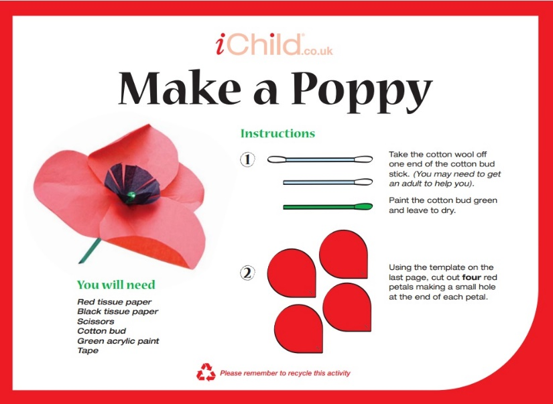

A Message From Me

Hello everyone, welcome to this month’s newsletter.

If you would like to talk to me then please contact me on the email address below. I can support you with subjects such as anxiety, sleep issues, emotions and behaviour

Teaching Remembrance

Free resources to use at home or within the classroom to support the understanding of Remembrance: [www.britishlegion.org.uk/get-involved/remembrance/teaching-remembrance](http://www.britishlegion.org.uk/get-involved/remembrance/teaching-remembrance)

Make a Poppy

You can show your support by making a cost-effective poppy or make lots of them for a creative window display. Follow the link for instructions: <https://www.ichild.co.uk/activities/view/1dyBNsBP93jJ5ifC2T4FGj/Make-a-Remembrance-Day-Poppy>

Sensory Autumnal Play Dough

Have fun with your child making play dough, and then even more fun playing with it afterwards.

**You’ll need:** 8 tbsp plain flour, 2tbsp table salt, 60 ml warm water, 1 tbsp vegetable oil, 2 tsp cinnamon or nutmeg, orange food colouring (optional)

* In a small bowl mix together the oil, water and food colouring.
* In a different bowl mix the flour, salt and spices.
* Pour the wet mixture into the dry mixture and stir together.
* Dust a surface with flour and plop the dough onto it, then knead until it all comes together.

Now you have your sensory dough! You can even add acorns or crunchy leaves to it to make it even more sensorily engaging.

Education Inclusion Family Advisor Newsletter

November 2022

**Does** your child have, or potentially have, an additional need or disability? Pinpoint (www.pinpoint-cambs.org.uk) have lots of information, advice and tips. For Cambridgeshire’s Local Offer go to www.cambridgeshire.gov.uk/residents/children-and-families/local-offer

**Contact me directly on**

** michelle.west@cambridgeshire.gov.uk**