Personal, Social, Health Education (PSHE) Including RSHE Policy
February 2024
Lead author/initiator(s): | Claire Tomlin (PSHE lead)
Next Review Date: | February 2025
Version No: | 2
Ratified by: | Spring Meadow Infant and Nursery School Local Governing Body
Date Ratified: | 8.2.2024
Review Timetable: | Annually

Spring Meadow Infant and Nursery School
Contents:
Statement of Intent
- Legal Framework
- Roles and Responsibilities
- Aims and Structure of the PSHE Curriculum
- Safeguarding
- Programme of Study
- Assessment
- Monitoring and Review
Statement of intent
PSHE at Spring Meadow aims to give children the knowledge, skills, and attitudes that they need to effectively navigate the complexities of life in the 21st Century. The curriculum covers key areas which will support children to make informed choices now and in the future around their health, safety, wellbeing, relationships and financial matters and will support them in becoming confident individuals and active members of society. Our PSHE curriculum also encompasses the British values and aims to embed our core values of kind, independent, inclusive, creative and knowledgeable.

Legal framework
This policy has due regard to all relevant legislation and statutory guidance including, but not limited to, the following:
- Education Act 1996
- Education Act 2002
- Children and Social Work Act 2017
- DfE (2019) ‘Relationships Education, Relationships and Sex Education (RSE) and Health Education’
- DfE (2022) ‘Keeping children safe in education 2022’ (KCSIE)
This policy operates in conjunction with the following school policies:
- Child Protection and Safeguarding Policy
- Complaints Procedures Policy
- Anti-Bullying Policy
- Behaviour Policy

Roles and responsibilities
The governing board is responsible for:
- Ensuring the school’s PSHE Policy is implemented effectively.
- Ensuring that the PSHE Policy, as written, does not discriminate on any grounds or protected characteristics.
The headteacher is responsible for:
- Ensuring the PSHE Policy is reviewed annually.
- Handling complaints regarding this policy, as outlined in the school’s Complaints Procedures Policy.
- Facilitating the day-to-day implementation and management of the PSHE Policy.
The PSHE coordinator is responsible for:
- Ensuring that all staff are following the PSHE policy and Cambridgeshire scheme of work
- Monitoring the quality of teaching and learning in PSHE
Ensuring there are adequate resources for staff to implement good quality PSHE lessons

Aims and structure of the PSHE curriculum
In Nursery a bespoke curriculum is followed using the PSED section of Development Matters alongside the PKC scheme of work. Reception follow the Cambridgeshire Scheme of work which includes units linked to relationships, emotions, keeping safe, healthy lifestyles and my body and growing up. These units allow sequenced progression into the Cambridgeshire scheme of work in KS1 which consists of units on citizenship, e-safety, myself and my relationships, life education, feelings, economic wellbeing, healthy and safer lifestyles and managing risks. Each strand is revisited year on year to allow children to build on prior learning of key skills and knowledge. The lessons are based upon the statutory guidance requirements for relationships and health education and the DFE’s recommendation from the PSHE Association’s Programme of Study for citizenship and economic wellbeing. The PSHE Cambridgeshire scheme of work supports the requirements of the Equality Act through direct teaching and the inclusion of diverse teaching resources. Alongside the Cambridgeshire scheme, which is taught in discreet weekly sessions in KS1 and Reception, school staff also respond to children’s needs and experiences on a daily basis and provide opportunities to share and listen to each other.

The school council is formed annually by each class democratically voting for a school council representative. The school councillors meet regularly with the PSHE lead to talk about and help make new decisions about matters that are important to the children in each class and the wider school community. The class representative also take on additional responsibilities during the year that are sometimes linked to charity events.
In Early Years the Cambridgeshire scheme is taught in three short sessions across the week and involves many stories and circle time activities.
In Key Stage 1 we use direct teaching via timetabled weekly lessons to teach PSHE. Pupils will be taught PSHE through a range of teaching and learning styles, including active techniques such as discussion and group work following suggestions in the Cambridgeshire scheme of work. Pupils’ opinions and questions will be responded to respectfully by teachers.
PSHE lessons will be tailored to the pupils being taught, with consideration of:
- Pupils’ ability.
- Pupils’ age.
- Pupils’ current knowledge on and readiness to learn about the topic being covered.
- Pupils’ cultural backgrounds.
- Pupils with EAL.
- Pupils with SEND or other needs.
To aid PSHE tailoring, the PSHE teacher will use discussions and other activities to ascertain pupils’ current knowledge and understanding of the subject being covered. Each lesson always begins with an activity to find out any prior knowledge so that teaching can then be adjusted to reflect the needs of the class.
The school will deliver relationships and health education as part of its timetabled PSHE programme. This is the statutory element of PSHE and therefore parents and carers are unable to withdraw a child from these lessons. Although parents have a right to withdraw children from sex education elements of the curriculum, there is no sex education taught within the curriculum at Spring Meadow.

Assemblies are used to support themes from the PSHE scheme as well as wider issues.

Safeguarding
Due to the nature of the matters discussed in PSHE, there may be a higher likelihood for safeguarding concerns to arise or be disclosed by pupils. In line with the school’s Child Protection and Safeguarding Policy, all staff will be aware of the indicators and risks of a range of safeguarding issues, and will follow the appropriate school procedures should a safeguarding concern be disclosed.
There is an element of PSHE in pastoral care, so the school will ensure that PSHE and pastoral care teams (THRIVE) work together to help pupils feel comfortable indicating that they may be vulnerable and at risk.
PSHE lessons will encourage pupils to discuss the issues raised in the lesson with a member of staff if they wish to do so. Pupils will also be made aware of how to raise concerns or make reports about potential safeguarding issues, and how reports will be handled. This also includes concerns and reports about a friend or peer.
Where beneficial, the DSL or deputy DSL will be involved in the development of safeguarding-related elements of the PSHE curriculum

Programme of study
The Spring Meadow long term plan is outlined below.
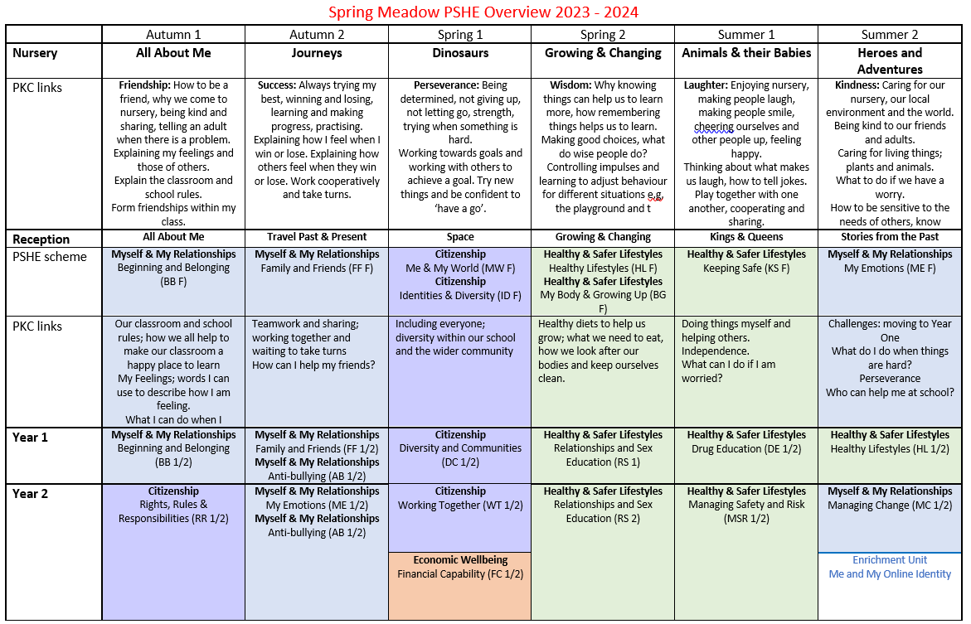

Assessment
The school will set the same high expectations of the quality of pupils’ work in PSHE as for other areas of the curriculum. A strong PSHE curriculum will be developed to build on knowledge pupils have previously acquired, including from other subjects, with regular feedback on their progress.
Lessons will be planned to ensure pupils of differing abilities are suitably challenged. Teaching will be assessed to identify where pupils need extra support or intervention.
In the EYFS pupils knowledge, understanding and skills will be assessed through formative assessments gained through designated learning times and time spent in the provision, which is then documented in floor books.

In KS1 Pupils are given the opportunity to evaluate and reflect on the learning. This is integrated into each unit to enable the children to see how their learning is progressing and where they need to take it next. Class teachers use formative assessment methods, observations they have made of the children both inside and outside the classroom, knowledge of participation in class and group discussions and the work they have produced during lessons, to make a judgement as to whether each child is working towards, at or above the expected level.

