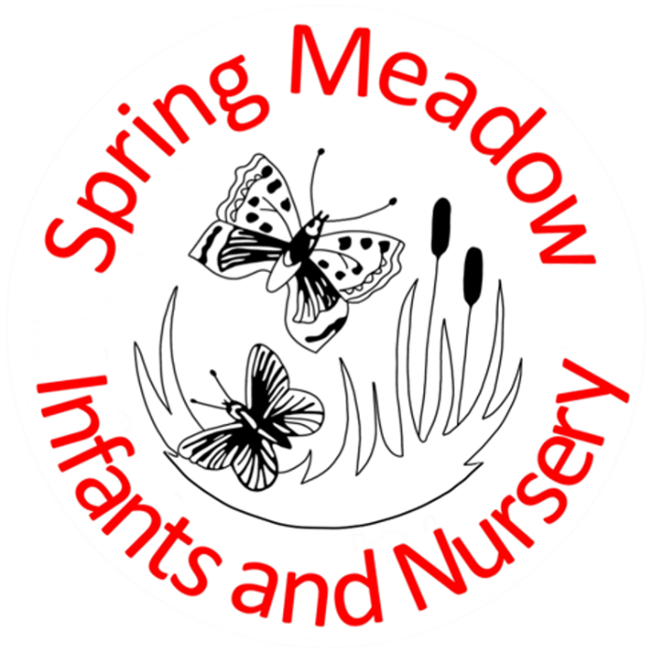
Menopause Policy

January 2024

Lead author/initiator(s): | Vicki Fowler
Next Review Date: | January 2024
Ratified by: | Spring Meadow Infant and Nursery Resources Committee
Date Ratified: | 24th January 2024
Review Timetable: | Bi-annually
Review: | January 2026

- Introduction

  - Menopause is a normal part of every woman’s life. This policy recognises that the menopause is an equality and occupational health and safety issue and that women may need appropriate flexibility, support and adjustments during the time of change before, during and after the menopause.

  - Spring Meadow Infant and Nursery School has a positive attitude towards the menopause and will treat all individuals with dignity and respect during this time and ensure that the workplace does not make symptoms worse. Spring Meadow Infant and Nursery School is committed to ensuring that women feel confident in discussing menopausal symptoms openly, without embarrassment and are able to ask for support and adjustments in order to continue to work safely in the organisation. For this reason, the menopause at work is an issue for men as well as women.

- The Legislative Setting:

Spring Meadow Infant and Nursery School undertakes to comply with its legal obligations as set out below:

  - The Health and Safety at Work etc. Act (1974) requires employers to ensure the health, safety and welfare of all workers. Under the Management of Health and Safety at Work Regulations 1999, employers are required to undertake general risk assessments which should include specific risks to menopausal women, see section 5.3.

  - The Equality Act (2010) prohibits discrimination against people on the grounds of certain ‘protected characteristics’ including sex, age and disability. Conditions linked to the menopause may meet the definition of an ‘impairment’ under the Equality Act and require reasonable adjustments.

- Status
  - This policy sets out procedures for members of staff and managers to follow in providing the right support to manage menopausal symptoms at work. If Spring Meadow Infant and Nursery School wishes to amend the Menopause Policy, consultation and negotiation on proposed changes will take place with staff and where necessary via the recognised trade unions.

- Aims

  - To create an environment where women staff members feel confident enough to raise issues about their symptoms and ask for support and adjustments at work.

  - To ensure that conditions in the workplace do not make menopausal symptoms worse and that appropriate adjustments and support are put in place, recognising that the menopause and perimenopause is an individual experience and therefore there is no ‘one size fits all’ solution.

  - To reduce sickness absence due to menopausal symptoms and retain valued staff in the workplace.

- What steps will we take as an employer?

  - Spring Meadow Infant and Nursery School will educate and inform managers and staff to be aware of how the menopause can affect working women, taking account of the particular circumstances in schools, and about the potential symptoms of menopause, and how they can support women experiencing them.

  - Where women members of staff feel uncomfortable going to their line manager, because he is a man, or someone much younger, or both, we will ensure that an alternative contact is available. Confidentiality will always be respected.

  - The risk assessments which we undertake will consider the specific needs of menopausal women, and, in doing so, we will consult with women staff members and share with all managers and new managers, requesting signatures to confirm that measures are understood and will be acted upon. Risk assessments will include consideration of temperature and ventilation issues and will also address welfare issues; such as access to toilet facilities and cold water, both during and outside break and lunch times.

  - Spring Meadow Infant and Nursery School will make adjustments where necessary to support individuals experiencing the menopause, and to ensure the workplace does not make their symptoms worse. These could include simple measures such as:

- Leaving doors open;

- Ensuring that windows can be safely opened;

- Ensuring that it is possible to regulate the temperature in a classroom or other room by turning down radiators (as long as the temperature does not drop below 18 degrees Celsius, this will be comfortable for all occupants);

- Provision of fans;

- Fitting blinds to windows;

- Establishing a system which allows cover for women who need to access toilet/washing facilities while they are teaching (to deal with heavy and recurring bleeding);

- Considering requests for changes to working arrangements, eg temporary part-time working;

- Swift permission for absence to attend menopause-related medical appointments; and

- Adjusting workplace procedures and processes to support and avoid any detriment to menopausal women.

This is not a definitive list of measures. Spring Meadow Infant and Nursery School will actively listen to women staff and where necessary, union reps and take on board other suggestions.

  - It is recognised that many of these practical and easy-to-institute changes to the workplace, that will make working life more bearable for menopausal women, will benefit all staff

- Roles and Responsibilities

It is recognised that everyone who works at Spring Meadow Infant and Nursery School has a role to play in ensuring a comfortable working environment for all staff, including women experiencing the menopause

  - All staff are responsible for:

- taking personal responsibility to look after their health;

- being open and honest in conversations with HR and Occupational Health;

- contributing to a respectful and healthy working environment;

- being willing to help and support their colleagues;

- accepting and supporting any necessary adjustments their colleagues request or are receiving as a result of their menopausal symptoms.

  - Senior Leadership Team

The most important and valuable thing a manager can do is listen and, wherever possible, respond sympathetically to any requests for adjustments at work.

    - All Senior Leadership Team will:

- familiarise themselves with this Menopause policy

- be aware of the potential impact of menopause on performance. (If someone’s performance suddenly dips, consideration will be given as to whether the menopause may be playing a part in this).

- encourage the member of staff to speak openly and honestly

- be ready and willing to listen and have open discussions about menopause, appreciating the personal nature of the conversation, and treating the discussion sensitively and confidentially and allowing adequate time for the discussion;

- record adjustments agreed, and actions to be implemented, via an action plan;

- ensure ongoing dialogue via a follow-up meeting;

- ensure that all agreed adjustments are adhered to and reviewed as regularly as necessary.

    - Where adjustments are unsuccessful, or if symptoms are proving particularly severe, the line manager may:

- discuss with the employee a referral to Occupational Health for further advice;

- review Occupational Health advice, and implement any additional recommendations;

- update the action plan and continue the review process.

  - Occupational Health

The role of Occupational Health is to:
- carry out a holistic assessment of the employee to ascertain whether or not the working environment may be exacerbating menopause symptoms.

- discuss with the employee what adjustments would help;

- signpost to other appropriate sources of help and advice.

