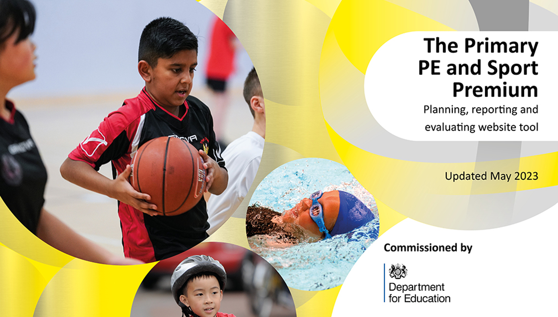
Details with regard to funding
Please complete the table below.

Total amount carried over from 2021/22 | £0
Total amount allocated for 2022/23 | £17360
How much (if any) do you intend to carry over from this total fund into 2023/24? | £0
Total amount of funding for 2022/23. To be spent and reported on by 31st July 2023. | £17360

Action Plan and Budget Tracking
Capture your intended annual spend against the 5 key indicators. Clarify the success criteria and evidence of impact that you intend to measure to evaluate for pupils today and for the future.

Academic Year: 2022/23 | Total fund allocated: £17360 | Date Updated: 10/07/2023
Key indicator 1: The engagement of all pupils in regular physical activity – Chief Medical Officers guidelines recommend that primary school pupils undertake at least 30 minutes of physical activity a day in school |  |  |  | Percentage of total allocation:
 |  |  |  | 36%
Intent | Implementation |  | Impact
Your school focus should be clear what you want the pupils to know and be able to do and about  what they need to learn and to  consolidate through practice: | Make sure your actions to achieve are linked to your intentions: | Funding allocated: | Evidence of impact: what do pupils now know and what can they now do? What has changed?: | Sustainability and suggested next steps:
All children should have the opportunity to take part in daily physical activity above and beyond their PE lessons. This should be of a high quality that inspires a love of PE and sport. | Daily lunchtime sessions run by qualified instructors. | £6270 | Children have the opportunity to take part in daily sport activities. They are able to try different sports and different types of games. This has helped inspire a love of sport and children tell us that they enjoy the opportunity to work with the coaches during lunch times. | Complete a resources audit to ensure we have the equipment for all children to join in.  Complete pupil voice surveys looking into the impact of the daily sessions and make improvements for 2023-2024.
Key indicator 2: The profile of PESSPA being raised across the school as a tool for whole school improvement |  |  |  | Percentage of total allocation:
 |  |  |  | 10%
Intent | Implementation |  | Impact
Your school focus should be clear what you want the pupils to know and be able to do and about  what they need to learn and to  consolidate through practice: | Make sure your actions to achieve are linked to your intentions: | Funding allocated: | Evidence of impact: what do pupils now know and what can they now do? What has changed?: | Sustainability and suggested next steps:
Use of the Get Set 4 PE curriculum to ensure progression in the PE curriculum is structured and ensuring all children get good curriculum coverage during their time at school. | Purchase the Get Set 4 PE programme  Provide staff with training time to look through the programme and analyse how best to utilise it. | £280  £1400 | PE teaching is now good and teacher skill has developed. The curriculum is well sequenced and gives children the opportunity to master basic skills before moving onto more complex ideas and strategies. | Continue to embed PE teaching across the school and ensure PE expectations form part of an induction session with new teachers.

Key indicator 3: Increased confidence, knowledge and skills of all staff in teaching PE and sport |  |  |  | Percentage of total allocation:
 |  |  |  | 28%
Intent | Implementation |  | Impact
Your school focus should be clear | Make sure your actions to | Funding | Evidence of impact: what do | Sustainability and suggested
what you want the pupils to know | achieve are linked to your | allocated: | pupils now know and what | next steps:
and be able to do and about | intentions: |  | can they now do? What has
what they need to learn and to |  |  | changed?:
consolidate through practice:
Teachers are confident in teaching PE and have seen high quality lessons taking place that can impact their own practice.  Staff in Rainbows are confidently able to deliver lessons to children in the IAU which meet their developmental needs. | Teachers to have opportunities to work alongside ActivePlay to see how they teach PE.  Rainbows staff to be targeted to work with Active Play to support all children to access high quality PE lessons. | £4940 | Teachers are confident in teaching PE and are able to adapt plans to successfully meet the needs of all pupils within their lessons. Quality of learning within PE has improved.  Children in the IAU have experienced fun, rewarding lessons with the support of Active Play and staff within the unit. Lessons are now developmentally appropriate and children’s confidence has improved throughout the year. | Assistant Head for curriculum to work with new teachers and nursery staff in 2023-2024 to ensure impact of this funding continues to be purposeful.
Key indicator 4: Broader experience of a range of sports and activities offered to all pupils |  |  |  | Percentage of total allocation:
 |  |  |  | 46%
Intent | Implementation |  | Impact
Your school focus should be clear | Make sure your actions to | Funding | Evidence of impact: what do | Sustainability and suggested
what you want the pupils to know | achieve are linked to your | allocated: | pupils now know and what | next steps:
and be able to do and about | intentions: |  | can they now do? What has
what they need to learn and to |  |  | changed?:
consolidate through practice:
All children to receive an extended opportunity to take part in Dance sessions with a dance instructor.  All children leave Spring Meadow being able to confidently ride a bike and gain a new life skill. | Lane Academy are coming in to do dance sessions weekly. Each class will be timetabled a half term of sessions.  Purchase of bikes to allow all children to leave Spring Meadow to be able to ride a bike. Purchase of balance and pedal bikes. Supported by SUSTRANS and ride to school sessions. | £4920  £2998.50 | Children’s fundamental movements and dance has improved across the year. Confidence with dance has also improved and children are happy to perform in front of peers and parents.  With support from SUSTRANS all Year 2 children have been able to ride a bike in school. This has improved confidence and Year 2 children have really enjoyed the process. | Teachers to watch the teaching of the instructor and use this as CPD to support teaching in future academic years.  SUSTRANS to support staff with how to teach children to ride a bike. Longer term plan to ensure bike riding becomes an additional part of our offer to all children.
Key indicator 5: Increased participation in competitive sport |  |  |  | Percentage of total allocation:
 |  |  |  | 2% + Previous Expenditure
Intent | Implementation |  | Impact
Your school focus should be clear | Make sure your actions to | Funding | Evidence of impact: what do | Sustainability and suggested
what you want the pupils to know | achieve are linked to your | allocated: | pupils now know and what | next steps:
and be able to do and about | intentions: |  | can they now do? What has
what they need to learn and to |  |  | changed?:
consolidate through practice:
Children to have the opportunity to take part in competitive games in PE. More opportunities will be provided at the end of Year 2. | Get Set for PE programme to be used to ensure competitive elements are included within PE.  ActivePlay to organise and run Sports Day with competitive elements. | £Cost incorporated in previous Key Indicators.  £350 | Sports Day was a big success and well received by children, staff and parents. Children were given opportunities to take part in competitive sport and this built on work done in PE lessons. | Active Play to continue to be used to support sports days and teacher knowledge. They will also run after school clubs to build on this year’s successes.

Signed off by
Head Teacher:
Date:
Subject Leader:
Date:
Governor:
Date:

